Air-conditioned! Great condition! • Always hangared!
ADS-B installed with sale • nice DA40’s are in short supply so don’t miss out on this one!

STATUS
- Total time airframe: 1,286 hours
- Engine: 1,286 hours
- Propeller: 948 hours since new – Hartzell 2-blade metal blades
- Annual completed: February 2019
- Minor propeller strike 2014, engine teardown and new propeller

EXTERIOR-LIKE NEW!
Exterior trim cardinal red / burgundy with charcoal metallic

INTERIOR-LIKE NEW!
Upgraded premier edition leather seats in grey leather upholstery with red piping accents
Removable custom-made pilot seat cushion
Upgraded carpet
AVIONICS
Garmin G1000 avionics system:
- GDU1040, 10-inch primary flight display (PFD)
- GDU1044, 10-inch multi-function display (MFD)
- GDC74 integrated, digital air data computer
- GRS77 solid-state attitude and heading reference system
- Dual Garmin GIA63W integrated radio modules with WAAS-enabled, IFR-approved GPS, VHF NAV and ILS; and VHF coms
- GMA1347 digital audio controller with digital ATC playback
- GMU44 magnetometer
- GEA71 airframe/engine interface unit
- Integrally lit, laser etched polycarbonate switch panel overlays
- Centrally located standby instrumentation, including electric attitude indicator, airspeed indicator, altimeter, compass
- 12v auxiliary power plug
- GTX33 integrated mode S transponder
- Garmin GDL69A satellite data link (subscription required)
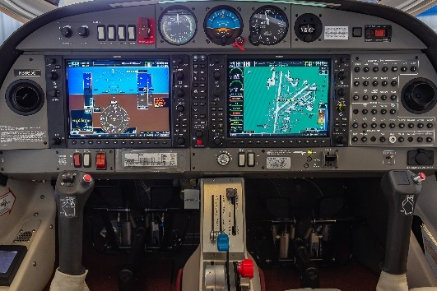
- Garmin VFR terrain awareness system
- 406 MHZ ELT
- Garmin SafeTaxi and FliteCharts
- Garmin synthetic vision technology
- Avidyne TAS 600 active traffic system
- GTX 345R (installed with purchase)
AUTOPILOT
Garmin GFC700 automatic flight control system (AFCS) including 2-axis digital autopilot with flight director
WAAS enabled dual GPS allows fully coupled ILS or WAAS approaches with audible “minimums” call-out and VNAV coupled step-downs

ADDITIONAL EQUIPMENT
- Performance landing gear kit
- 4-way baggage compartment system

- Extended range fuel tanks (50 USG)
- AmSafe air bag restraints (front seats)
- Electrically operated rudder pedals
- Electronic carbon monoxide detector
- Power flow tuned exhaust system
- 4-way baggage compartment
- Lopresti “boom-beam” landing and taxi lights
- Cabin cool air-conditioning system
