NEW CONTINENTAL CD 135 ENGINES JUST INSTALLED WITH 2,100 HOUR TBR

ADS-B IN OUT COMPLIANT • NEW LEATHER INTERIOR • KNOWN ICE • LONG RANGE FUEL

FRESH ANNUAL • NO DAMAGE HISTORY

STATUS
- Airframe: 3,155 hours (subject to change)
- Engines: 3.5 hours since new, 2,100-hour TBR
- Propellers: 153/89 hours SPOH 2019
- Annual completed: June 2020
- No damage history
- Useful load: 1,003.0 lbs.

EXTERIOR/INTERIOR
- Exterior trim: white with red, black, and silver accents
- Interior: new grey leather interior – reupholstered seats in June 2020

AVIONICS
- Garmin G1000 integrated glass cockpit;
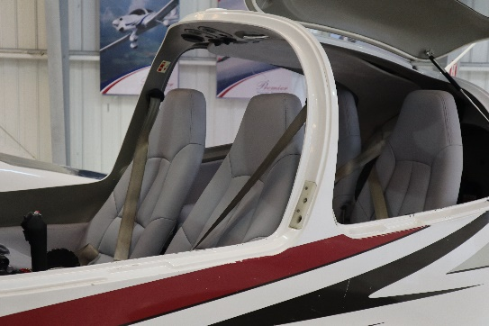
- GDU 1040, 10-inch primary flight display
- GDU 1040, 10-inch multi-function display
- Dual Garmin GIA 63 COM/NAV/GPS – non WAAS
- GMA1347 digital audio system
- GTX 345R ADS-B in/out transponder
- GRS 77 solid-state attitude heading reference system
- GDC 74 digital air data computer
- GMU 44 magnetometer
- VFR terrain awareness system
- Garmin GDL69A – satellite weather and XM radio (subscription required)
- GEA 71 airframe/engine interface unit
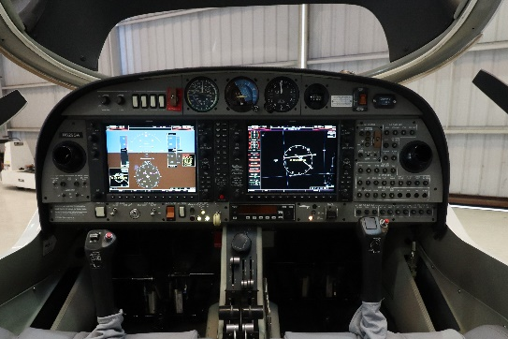
- Standby instruments (compass, horizon, air speed indicator, altimeter)
- Composite cabin and safety seats (up to 26g)
- Lightning protection system
- Fire extinguisher
- Failsafe airframe design
- 3-point safety belts automatic (all seats)
- Hydraulic retractable landing gear
- High intensity discharge landing and taxi lights
- Position and anti-collision lights
- 4-way baggage compartment system
- Nose baggage compartment accessible from both sides
- ELT Artex 406 MHZ

AUTOPILOT
- Honeywell KAP140 Dual Axis Autopilot with Altitude Hold and Preselect

ADDITIONAL EQUIPMENT
- Long range fuel tanks– (76 us gallons)
- TKS- known icing
