Brand new Diamond Da62! G1000 NXi, radar, air conditioning and seven seats!

POWER PLANT

Austro Engine AE 330 turbocharged common rail injected 2.0-liter diesel engine with 180 HP and EECU single lever control system

MT Propeller MTV-6-R-C-F/CF 194-80 three-blade constant speed

EXTERIOR/INTERIOR
- Hydraulic retractable landing gear
- Heated pitot tube and static port
- Entry steps and entry grips in aircraft color
- Registration markings
- Custom exterior metallic paint teal on black / silver stripes
- Electrically operated flap system
- Landing and taxi lights (HID-Xenon)
- LED integrated position and strobe lights
- Adjustable backrest (with adjustable lumbar support)
- USB power outlets - pilot, copilot, passenger 2nd row
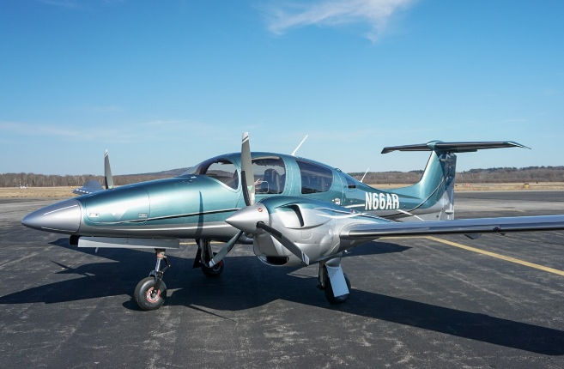
- Overhead ambient cabin, reading and map lights
- Electrically operated adjustable rudder pedals
- Pilot and copilot middle armrest
- Dual headset plugs (6-pin headset connector and

standard jack connector)
- Sun visors for pilot and copilot

AVIONICS
- Avionics/Radios G1000 NXi Integrated Flight Deck System, includes:
- 2x Garmin GDU 10-inch Flight Display (PFD & MFD)
- Garmin GEA 71 Airframe/Engine Interface Unit
- 2x Garmin GIA 63 WAAS COMM/NAV/GPS/GS/LOC
- Garmin GMA 1347 Digital Audio System
- Garmin GRS 79 Attitude Heading Reference System
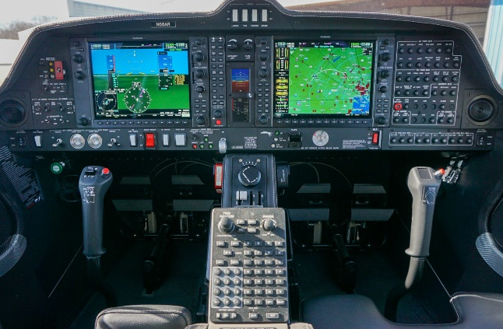
- Garmin GDC 72 Digital Air Data Computer
- Garmin GMU 44 Magnetometer
- Garmin GFC 700 Automatic Flight Control System
- including Yaw Damper
- Garmin ChartView Approach Plates (Subscription
- Required)
- ELT 406 MHz
- Second Digital Standby Attitude Module (MD-302 SAM)

ADDITIONAL EQUIPMENT
- Garmin GCU 476 keypad
- Garmin synthetic vision
- Garmin GTX 345R transponder ADS-B (in and out)
- Garmin GDL 69A SAT WX (subscription required)
- Air Conditioning/RACC II system
- TKS deicing system
- Oxygen system
- Third row seating configuration
- Removable right-hand control stick
- 86 U.S. gallon long range fuel tanks
- Nose baggage compartment accessible from both sides
- Pitot cover, tow bar, tool kit, control gust lock
- First aid kit, fire extinguisher

SAFETY CONCEPT
- Composite cabin and safety seats
- “FAILSAFE” airframe and wing design
- Multipath lightning protection system
- Three-point safety belts automatic (all seats)
- Garmin ESP (Electronic Stability Protection)

