All-weather TKS (FIKI)-equipped Ovation • WAAS equipped
ADS-B in/out • beautiful paint and interior

STATUS
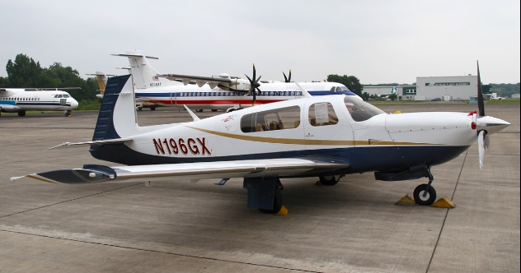
- Total time: 1,630 hours since new (subject to change)
- Engine: 1,630 hours since new, Continental Platinum I0-550-G
- Prop: 1,630 since new, Hartzell 3-blade
- Annual: completed December 2019
- No damage history

EXTERIOR/INTERIOR
- Exterior trim: Matterhorn White over Sapphire Blue with Las Vegas Gold and burgundy accents
- Interior: beige leather interior

AVIONICS
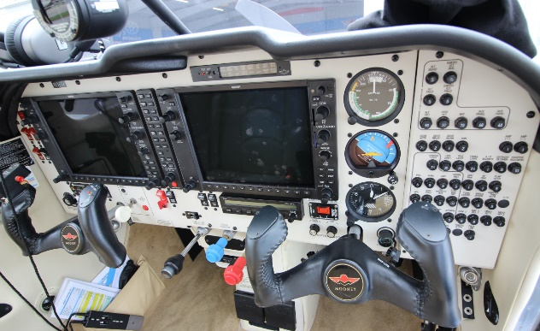
- Garmin GDU 1040, 10” Primary Flight Display, three-axis flight dynamics, air speed, altitude, vs, hsi with perspective modes
- Garmin GDU 1042, 10” Multi-Function Display
- Garmin GDC 74a Integrated Digital Air Data Computer, constant display of TAS, CAS, wind direction, VSI and TAT
- GRS77 Solid-State Attitude and Heading Reference System
- Dual Garmin GIA63W, WAAS integrated radio modules with IFR-approved GPS, VHF navigation with ILS and VHF communication with 16-watt 8.33-khz transceivers
- GMA 1347 Digital Audio Panel with marker beacon and intercom
- GTX 345R Integrated ADS-B In / Out Transponder
- Garmin GEA 71 Airframe/Engine Interface Unit
- Garmin GMU 44 Magnetometer
- Stand-by instrumentation, including ADI, A/S, altimeter, and magnetic direction indicator with emergency lighting
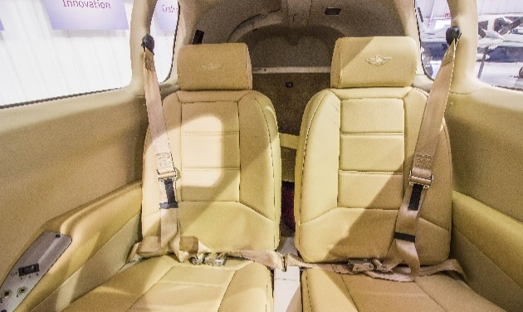
- Garmin GDL 69A Satellite Data Link – weather radar, satellite text, graphic weather data link and audio infotainment
- attitude indicators stand-by electrical
- L3 WX-500 Stormscope

AUTOPILOT
- STEC 55X 2-axis Autopilot

ADDITIONAL EQUIPMENT
- 89 gallons fuel capacity
- TKS deice system – flight into known icing approved (FIKI)
- Oxygen system
- AmSafe airbag pilot and copilot seats only
- Platinum engine upgrade
- installation of hot-wire plugs for Bose (pilot and copilot)

