ONE OWNER DA40’S ARE RARE, DON’T MISS THIS ONE!
NO DAMAGE, ADS-B IN AND OUT, GFC700, SYNTHETIC VISION

STATUS
- AIRFRAME: 445 HOURS
- ENGINE: 445 HOURS
- PROPELLER: 445 HOURS
- ANNUAL: NOVEMBER 2018
- NO DAMAGE HISTORY

EXTERIOR/INTERIOR
- EXTERIOR TRIM: VIVID BLUE WITH GOLD ACCENTS
- INTERIOR: STANDARD FACTORY CURRY LEATHER

AVIONICS
- GARMIN G1000
- GDU1040, 10 INCH PRIMARY FLIGHT DISPLAY
- GDU1044, 10 INCH MULTI FUNCTION DISPLAY
- GDC74 INTEGRATED, DIGITAL AIR DATA COMPUTER, CONSTANT DISPLAY OF TAS, CAS, WIND DIRECTION AND STRENGTH, VSI AND OAT
- GRS77 SOLID-STATE ATTITUDE AND HEADING REFERENCE SYSTEM
- DUAL GARMIN GIA63W INTEGRATED RADIO MODULES WITH WAAS-ENABLED, IFR-APPROVED GPS, VHF NAV AND ILS; AND VHF COMS
- GMA1347 DIGITAL AUDIO CONTROLLER WITH DIGITAL ATC PLAYBACK
- GMU 44 MAGNETOMETER
- GEA71 AIRFRAME/ENGINE INTERFACE UNIT
- INTEGRALLY LIT, LASER ETCHED POLYCARBONATE SWITCH PANEL OVERLAYS
- CENTRALLY LOCATED STANDBY INSTRUMENTATION, INCLUDING ELECTRIC ATTITUDE INDICATOR, AIRSPEED INDICATOR, ALTIMETER, COMPASS
- 12 V AUXILIARY POWER PLUG
- GARMIN GDL69A SATELLITE DATA LINK (SUBSCRIPTION REQUIRED)
- GARMIN TERRAIN AWARENESS SYSTEM
- 406 MHZ ELT
- GARMIN SAFETAXI AND FLITECHARTS (SUBSCRIPTION REQUIRED)
- GARMIN SYNTHETIC VISION TECHNOLOGY (SVT)
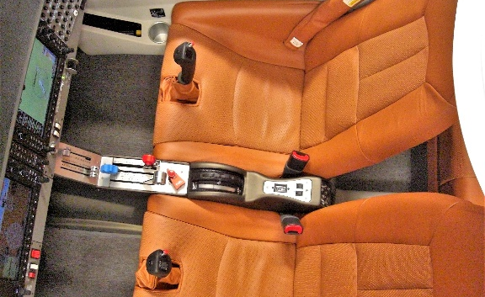
- GARMIN GTX345R TRANSPONDER WITH ADS-B IN AND OUT

AUTOPILOT
- GARMIN GFC700 AUTOMATIC FLIGHT CONTROL SYSTEM (AFCS) INCLUDING 2-AXIS DIGITAL AUTOPILOT WITH FLIGHT DIRECTOR
- WAAS ENABLED DUAL GPS ALLOWS FULLY COUPLED ILS OR WAAS APPROACHES WITH AUDIBLE “MINIMUMS” CALL-OUT AND VNAV COUPLED STEP-DOWNS

ADDITIONAL EQUIPMENT
- HARTZELL 2-BLADE SCIMITAR STRUCTURAL COMPOSITE PROPELLER
- PERFORMANCE LANDING GEAR KIT
- 4 WAY BAGGAGE COMPARTMENT SYSTEM
- WINTER KIT
- EXTENDED RANGE FUEL TANKS (50 USG)
- AMSAFE AIR BAG RESTRAINTS (FRONT SEATS)
- ELECTRICALLY OPERATED RUDDER PEDALS
- ELECTRONIC CARBON MONOXIDE DETECTOR
- HIGH INTENSITY DISCHARGING LANDING AND TAXI LIGHTS
- POWER FLOW TUNED EXHAUST SYSTEM
- ENLARGED “BUBBLE CANOPY”
ARMRESTS (FRONT CANOPY SIDE RAIL PILOT AND COPILOT)

