Nicely Upgraded A36, Aspen Pro, GTN 750, ADS-B Out Compliant, No Damage History!

STATUS
- TOTAL TIME, AIRFRAME: 3,613 HOURS
- ENGINE: 874 HOURS SMOH BY CERTIFIED ENGINES
- PROPELLER: 942 HOURS SMOH
- ANNUAL: DUE AUGUST 2019 – FRESH ANNUAL WITH SALE
- NO DAMAGE HISTORY

EXTERIOR/INTERIOR
- EXTERIOR TRIM: WHITE WITH BLUE, GOLD AND RED ACCENTS
- INTERIOR: BEIGE FABRIC

AVIONICS
- ASPEN EVOLUTION PFD WITH SV (SYNTHETIC VISION) AND BACKUP BATTERY
- GTN 750 WITH WAAS
- GARMIN FLIGHT STREAM FS210 (RECEIVES FLIGHT PLAN FROM IPAD AND PUSHES TO GTN750)
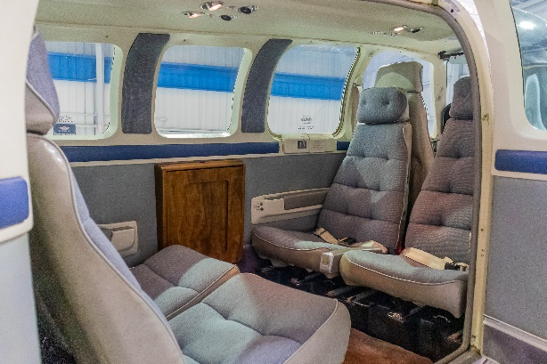
- GARMIN GNC255 NAV/COM (WIRED TO MODERN CONTINENTAL GS AND TO ASPEN)
- GARMIN GMA350 AUDIO PANEL 6PLACE INTERCOM WITH FRONT AND REAR MUSIC INPUTS (2- INPUTS)
- PILOT AND COPILOT LEMO PLUGS
- QUICK FREQUENCY CHANGE BUTTON ON PILOT YOKE
- KING KT74 TRANSPONDER WITH ADSB OUT (2020 MANDATE COMPLIANT)
- JPI 750 WIRED TO GTN750 FOR TOTAL FUEL ONBOARD AND FUEL REMAINING WITH RESERVES
- INSIGHT G3 GEM
- MID CONTINENTAL #2 VOR GLIDE SCOPE INDICATOR
- GARMIN 796 WIRED TO GTN750 FOR AUTOFILL WITH XM RADIO AND WX (DISPLAYS WEATHER AND TRAFFIC)
- GDL39 3D POWER HARDWIRED TO PANEL (WITH HRS AND FIB-B WEATHER AND TIS TRAFFIC)
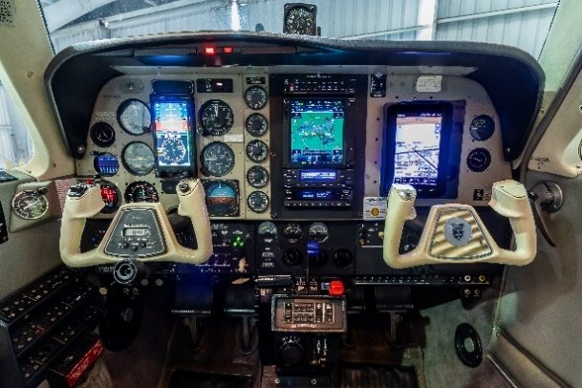
- 406 ELT- GPS

AUTOPILOT
- KING KFC 200 AUTOPILOT WITH ALT PRE-SELECT ON ASPEN

ADDITIONAL EQUIPMENT
- FACTORY AIR CONDITIONING
- LED TAIL BEACON MOD
- LED TAXI LIGHT
- LED LANDING LIGHT
- 3M TINTED REAR WINDOWS
- GAMI INJECTORS (.5 GALLON SPREAD)
- D-SHANNON ENGINE BAFFLES
- MCCAULEY 3-BLADE PROPELLER WITH ELECTRIC PROP HEAT

