2016 Cessna T206H HD Turbo Stationair |  |  |  |  |  |  |  |  | N718JD Ser#T20609256
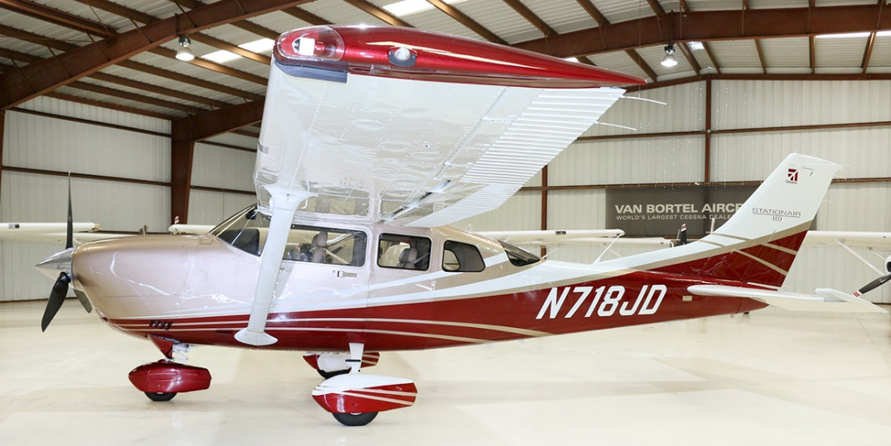
521 Total Time
 |  |  |  |  |  |  | Leather Seats
 | Standard Empty Weight: 3,789 (STC SA09860AC) |  |  |  |  |  | 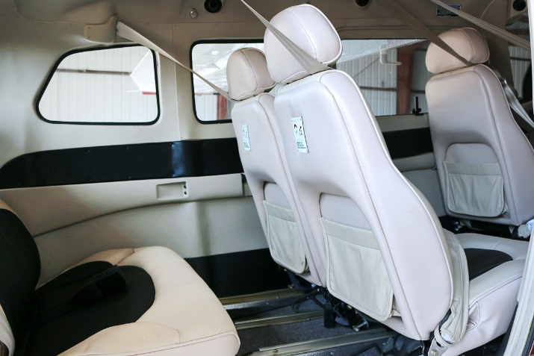
 | Exterior
 | Two Tone Gold Pearl w/Maroon
 | Wheel Fairings
 | Interior
 | Luxor II Leather Seats
 | Systems
 | Gross Weight Increase
Standard Avionic Features
Digital Audio Panel w/Marker Beacon/Intercom - GMA 1347
Extended Squitter Transponder with ADS-B Out and In - GTX 345R
NAV/COM/GPS/WAAS w/GS #1 - GIA 63W
NAV/COM/GPS/WAAS w/GS #2 - GIA 63W
Primary Flight Display - GDU 1054B
Multi-Function Display - GDU 1054B
Engine/Airframe Computer - GEA 71
Combined Attitude & Heading Reference System AHRS and Air Data Computer w/OAT Probe - GSU 75
Magnetometer - GMU 44
Garmin SafeTaxi & FliteCharts
Autopilot - GFC 700
Go-Around Switch
Electric Trim
A/P Disconnect
Control Wheel Steering Button
Electronic Checklists
ME406 Two Frequency Emergency Locator Transmitter
Emergency Locator Transmitter Remote Mounted Switch
Backup Attitude Gyro, Altimeter and Airspeed Indicator
Control Wheel Push-To-Talk Switch-Pilot/Copilot
Mic & Phone Jacks-Pilot/Copilot/Passengers
Auxiliary Stereo Input Jack
Hand Held Microphone
WARRANTY:
Propeller: 12/20/2019
 | Avionics
 | Garmin GTS800 TAS
 | Garmin Synthetic Vision Technology (SVT)
 | Garmin WX500 Stormscope
 | Garmin XM Weather and Radio Data Link (GDL 69)
 | ADS-B In/Out

