1978 CESSNA 414AW RAM VII
N678JS – SN 414a-0090 TRADES WELCOME!
Price: INQUIRE

YOU HAVE TO TAKE A LOOK AT THIS ONE! SIDS COMPLIANT, WINGLETS, VORTEX, GENERATORS AND WITH GROSS WEIGHT INCREASE TO 7,100 POUNDS! WOULD LIKE
TO TRADE UP TO A CITATION SP OR CJ!

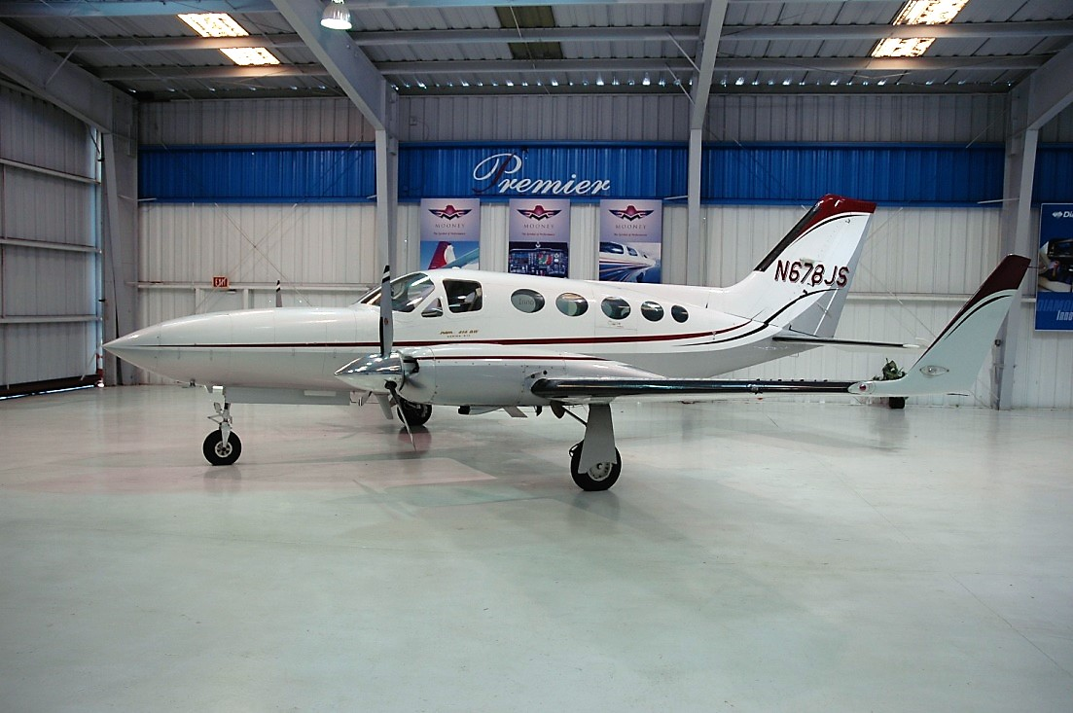status
- TOTAL AIRFRAME TIME: 8,187 HOURS
- LEFT ENGINE TIME: 538 SMOH (50 STOP)
- RIGHT ENGINE TIME: 538 SMOH (50 STOP)
- LEFT AND RIGHT PROP: 538 HOURS SNEW
- ANNUAL: FEBRUARY 2019
- USEFUL LOAD: 2,251 POUNDS

EXTERIOR/INTERIOR
- WHITE WITH BURGUNDY AND GREY STRIPES
- GREY LEATHER INTERIOR
- EIGHT-PLACE EXECUTIVE SEATING

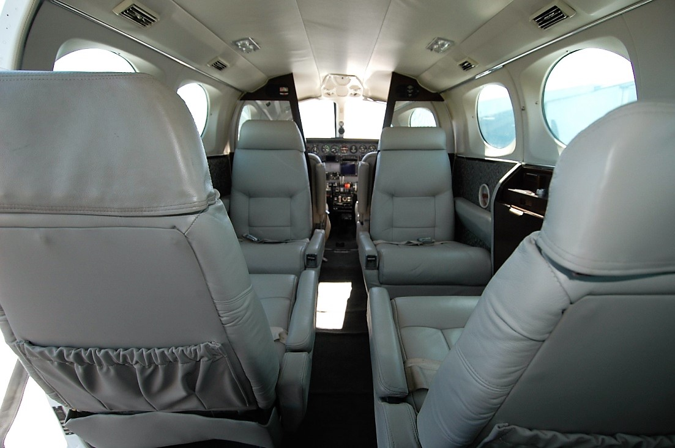AVIONICS
- GARMIN 430 GPS
- APOLLO MX 20 WITH WX500 STORMSCOPE
- GARMIN SL30 NAVB/COM
- GMA 340 AUDIO PANEL WITH INTERCOM
- DUAL NAV/COM’S
- DUAL GLIDE-SLOPE
- ALTITUDE ENCODER
- DUAL TRANSPONDERS CESSNA AND GARMIN GTX327
- SHADIN FUEL FLOW
- RADAR ALTIMETER

AUTOPILOT
- 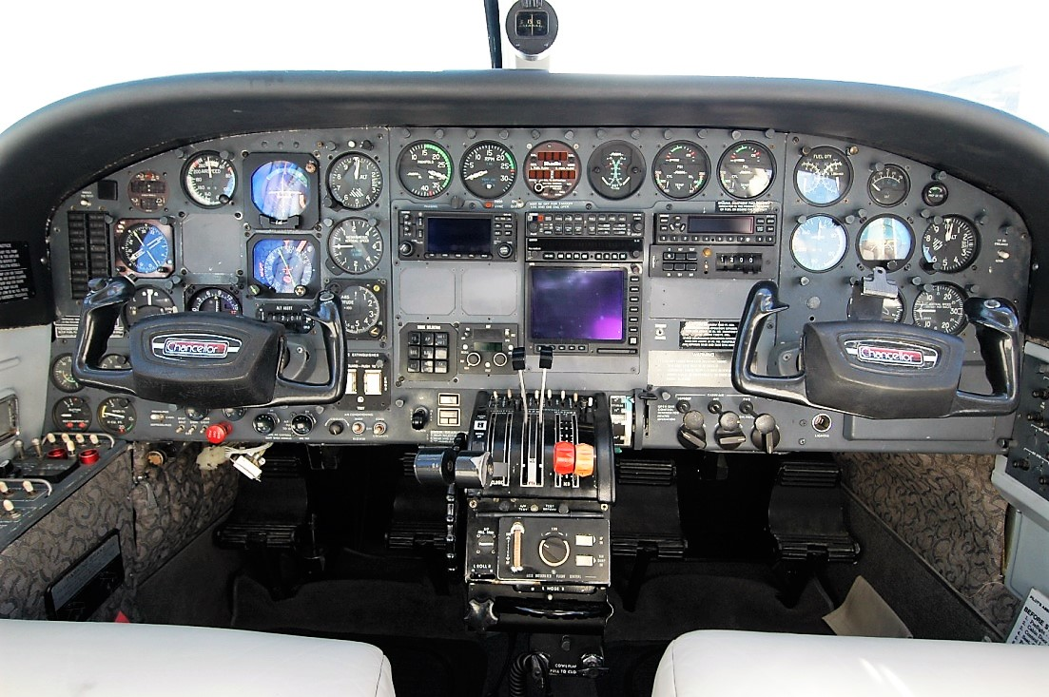800 B IFCS WITH HEADING SITUATION INDICATOR AND FLIGHT DIRECTOR WITH ALERT AND PRE-SELECT, YAW DAMPENER

ACCESSORY EQUIPMENT
- COPILOT INSTRUMENTS
- FACTORY AIR CONDITIONING
- DE-ICE BOOTS AND HOT PROPS
- PROPELLER SYNCHRONIZATION
- KNOW ICE WITH GLASS WINDSHIELD
- WING SPAR MODIFICATION INSTALLED 2008
- FIRE DETECTION AND EXTINGUISHING SYSTEM
- RAM VII ENGINE, PROP AND WINGLETS COMPLETED 12/2005
- RAM WINGLETS, VORTEX GENERATORS AND INCREASED GROSS WEIGHT

