ADS-B Out! SVT! Active Traffic (TAS)!
2010 Cessna T182T Turbo Skylane with G1000, GFC700, WAAS
N345CM Ser#T18209016

499 Total Time Since New
66 since IRAN Inspection by Textron Lycoming
95 Since New Propeller

Avionics:
GMA-1347 Digital Audio Panel with Marker Beacon/Intercom
GTX-33ES Transponder-Mode S w-TIS & ADS-B Out
GIA-63W NAV/COM/GPS/WAAS with GS #1
GIA-63W NAV/COM/GPS/WAAS with GS #2
GDU-1044B Primary Flight Display (PFD)
GDU-1044B Multi-Function Display (MFD)
GEA-71 Engine/Airframe Computer
GRS-77 AHRS
GDC-74A Air Data Computer with OAT Probe
GMU-44 Magnetometer
Garmin SafeTaxi & FliteCharts
GFC-700 Autopilot
• Go-Around Switch
• Electric Trim
• A/P Disconnect
• Control Wheel Steering Button
GDL-69A Flight Information System (FIS) with XM Radio
WX-500 Stormscope
Electronic Checklists
ME406 Two Frequency Emergency Locator Transmitter
Emergency Locator Transmitter Remote Mounted Switch
Backup Attitude Gyro, Altimeter and Airspeed Indicator
Control Wheel Push-To-Talk Switch-Pilot/Copilot
Mic & Phone Jacks-Pilot/Copilot/Passengers
Auxiliary Stereo Input Jack
Antennas:
• Marker Beacon Antenna
• Transponder Antenna
• VHF/GPS Antenna (2)
• XM Antenna
• NAV Antenna
• Emergency Locator Transmitter External Antenna
• Stormscope Antenna
Pitot System - Heated
Static System
Hand Held Microphone
Alternate Static Source
Compass
Amsafe Inflatable Seat Belts & Shoulder Harness STC, Inertia Reel, All Seats

Additional Equipment:
Synthetic Vision Technology (SVT)
Active Traffic (TAS)
ADS-B Out
Hot Prop
Built In Oxygen

Exterior:
Matterhorn White with Medium Concorde Blue Metallic and Antique Silver painted stripes

Interior:
Leather Seat Surfaces, Pebble Leather with Perforated Black Leather Insert
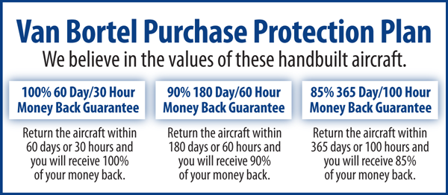

We fly the aircraft to your ramp for inspection by you and your mechanic at no cost or obligation to you.

All Specifications Subject To Verification Upon Inspection

Trades Welcome • Always Hangared • No Corrosion

