ABSOLUTELY LIKE NEW IN EVERY WAY – EXCEPT FOR THE PRICE! FOLDING SEATS IN LATEST PIPER CONFIGURATION ELEGANT THREE-TONE PAINT AND DUNE LEATHER SEATING
AIRCRAFT HAS NEW STYLE MOTOR MOUNT AND NEW STYLE FUEL SENDERS
WE PROVIDE COMPLETE TURNKEY SERVICE—PREBUYS, INSURANCE APPROVED TRAINING, DELIVERY AND WE TAKE TRADES!

STATUS
- AIRFRAME TOTAL TIME: 570 HOURS
- ENGINE TOTAL TIME: 570 HOURS
- PROPELLER TOTAL TIME: 464 HOURS SINCE OVERHAUL—MAY OF 2014
- ANNUAL: JANUARY 2019 BY PREMIER AIRCRAFT SERVICE PER PIPER INSPECTION GUIDE
- ALL TIME LIFE ITEMS UP TO DATE
- SEE FRED AHLES FOR DESCRIPTION OF PRIOR DAMAGE HISTORY

EXTERIOR/INTERIOR
- ELEGANT PAINT COLORS– WHITE OVER METALLIC BLACK WITH METALLIC GOLD TRIM—LIKE NEW
- DARK TAN LEATHER SEATS
- DELUXE SIX SEAT CLUB INTERIOR GROUP
- BUILT-IN EXECUTIVE WRITING TABLE

AVIONICS
GARMIN G1000 AVIONICS SUITE:
- SYNTHETIC VISION
- 10” PFD - PILOT AND CO-PILOT SINGLE15” MFD
- GMA-1347 AUDIO PANEL
- DUAL GIA-63W NAV/COM/GPS WAAS ENABLED
- DUAL GDC 74A AIR DATA COMPUTERS
- GTX 33 TRANSPONDER#1
- GWX-68 WEATHER RADAR
- GCU-476 KEYPAD
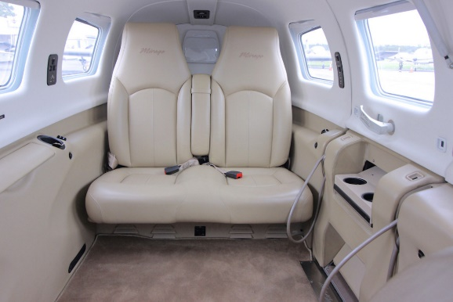
- GDL 69A SATELLITE RADIO/WEATHER RECEIVER
- JEPPESSEN CHARTVIEW
- GARMIN FLITECHARTS AND SAFE TAXI
- STAND-BY FLIGHT INSTRUMENTS
- ENHANCED SITUATIONAL AWARENESS PACKAGE
- FLIGHT INTO KNOWN ICING (FIKI)

AUTOPILOT
- GFC 700 AUTOPILOT WITH GMC-710 AP CONTROLLER

ADDITIONAL EQUIPMENT
- AMSAFE SEATBELTS - PILOT AND COPILOT POSITIONS
- SPEED BRAKES
- YAW DAMPER SYSTEM
- PIPERAIRE AIR CONDITIONING
- HARDWIRED COCKPIT FOR BOSE HEADSETS
- LONG RANGE FUEL TANKS—140 GALLONS

