Your flying “SUV” is ready for delivery! G1000 NXi, Radar, Jepp Charts, and more.
Air conditioning, dual 5 and 7 seats configurations included. Full Factory warranty.
Short-term dealer leaseback opportunity available. Call us for more details.

STATUS
- Factory new – ferry time only, Available for immediate delivery
POWER PLANT
- 2x Austro engine AE 330 turbocharged common-rail injected 2.0-liter diesel engine with 180 HP and EECU single-lever control
- 2x MT propeller MTV-6-R-C-C/CF 194-80 3-blade constant speed propeller
EXTERIOR
- Sapphire blue metallic and silver paint scheme
- Hydraulic retractable landing gear
- Heated pitot tube and static port
- Electric operated flap system
- HID Xenon landing and taxi lights
- LED position and strobe lights
INTERIOR
- Elegant onyx interior option with seating for seven
- Adjustable backrest with adjustable lumbar support
- USB power outlets - pilot, copilot, passenger 2nd row
- Instrument lighting
- Overhead ambient cabin, reading and map lights
- Electrically adjustable rudder pedals for pilot/copilot
- Pilot and copilot middle armrest
- Sun visors for pilot and copilot
- Dual headset plugs (6-pin headset connector and standard jack connector)

AVIONICS
- Integrated Garmin G1000 NXi Glass Panel Cockpit, including:
  - 2x Garmin GDU 105X 10-inch Flight Displays (PFD and MFD)
  - Garmin GEA 71B Airframe/Engine Interface Unit
  - 2x Garmin GIA 71B WAAS COM/NAV/GPS/GS/LOC
  - Garmin GMA 1360 Digital Audio System
  - Garmin GRS 79 Attitude Heading Reference System
  - Garmin GDC 72 Digital Air Data Computer
  - Garmin GMU 44 Magnetometer
  - Garmin GFC 700 Automatic Flight Control System with yaw damper
  - Garmin GTX 335 R remote ADS-B transponder
  - Garmin FliteCharts Approach Plates (subscription required)
  - ELT 406 MHz
  - 2nd Digital Standby Attitude Module (MD-302 SAM)

AVIONICS – INSTALLED OPTIONS
- Avidyne TAS 605 Traffic Advisory System
- Garmin GWX 70 Weather Radar
- FliteStream 510
- Garmin GCU 476 Keypad
- Garmin Synthetic Vision Technology
- Garmin GDL 69 XM SAT WX (subscription required)
- Jeppesen Chartview (subscription required)
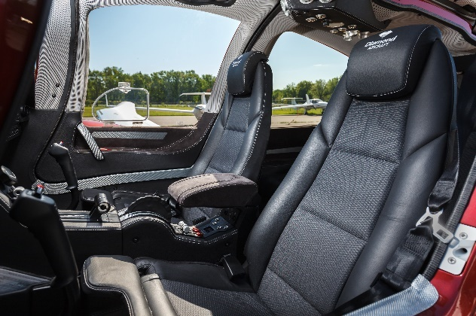
ADDITIONAL – INSTALLED OPTIONS
- Air Conditioning/RACC II System (powered by an additional alternator)
- TKS deicing system
- Oxygen system
- 3rd row seating configuration (rear seating for two additional passengers)
- 5-seat cargo tray option included
SAFETY CONCEPT
- Composite cabin and safety seats
- “FAILSAFE” airframe and wing design
- Multipath Lightning Protection System
- 3-point safety belts automatic (all seats)
- Garmin ESP (Electronic Stability Protection)
OTHER EQUIPMENT
- 86 U.S. gallon Long Range Fuel Tank
- Baggage compartment
- Nose baggage compartment accessible from both sides
- Tow bar, tool kit, control gust lock
- First aid kit, extinguisher, emergency axe, egress hammer
- Jet Shades second and third row
FACTORY WARRANTY & TRAINING
- Two-year factory warranty
- PistonPower airframe and engine maintenance program available at additional cost – call for details
- Factory-approved familiarization training

