This Superb Meridian Has Just Completed a Thorough Annual at Sun Aviation in Vero Beach. Includes New Garmin Touchscreen 650 GPSS! Excellent Condition Inside and Out!

Sale Includes Premier Training Package. We Take Trade and Handle Financing and Insurance

STATUS
- TOTAL TIME, AIRFRAME: 2,025 HOURS
- ENGINE: 2,025 HOURS -187 HOURS SINCE HOT SECTION INSPECTION
- PROPELLER: 0 HOURS SINCE PROP OVERHAUL IN JULY 2019
- ANNUAL: JULY 2019 BY SUN AVIATION
- SEE FRED AHLES FOR REPAIR HISTORY

EXTERIOR/INTERIOR
- EXTERIOR TRIM: PAINT SHOWS SUPERB CARE — MILKY WAY UPPER OVER LIGHT BURGUNDY METALLIC LOWER BASE COMPLEMENTED WITH NAVY BLUE AND TIBETAN GOLD METALLIC ACCENT STRIPES
- INTERIOR: LIGHT KHAKI LEATHER SEATS AND SIDE PANELS, CREAM ULTRA-LEATHER HEADLINER; BEIGE WOOL CARPET, AND MAHOGANY LAMINATE CABINETRY

AVIONICS
- AVIDYNE FLIGHTMAX ENTREGRA - FLAT PANEL DISPLAY SYSTEM WITH:
  - DUAL EXP 5000 PRIMARY FLIGHT DISPLAYS WITH HSI
  - EX5000 MULTI-FUNCTION DISPLAY
  - DUAL GARMIN GNS-650 GPS WITH WAAS
  - DUAL GARMIN GTX-330 TRANSPONDERS
  - HONEYWELL RDR-2000 VP COLOR RADAR—DISPLAYS ON MFD
  - DUAL EXP 5000 PFD RMI
  - DUAL ADAHRS
  - GARMIN GMA 340 AUDIO PANEL WITH MARKER BEACONS AND INTERCOM
  - HONEYWELL IHAS 8000 SITUATIONAL AWARENESS PACKAGE WITH COLOR RADAR, TRAFFIC AND TERRAIN AVOIDANCE PACKAGE
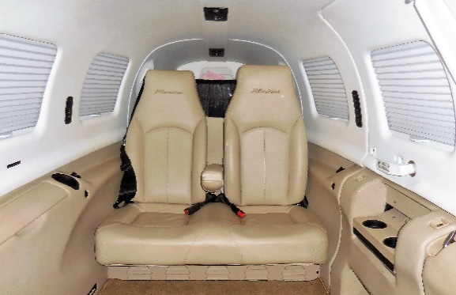
  - AVIDYNE MULTI-LINK SYSTEM WITH XM WEATHER, TAWS, TRAFFIC AND C-MAX ELECTRONIC APPROACH CHARTS, MECHANICAL BACKUP ALTIMETER, AIRSPEED AND ATTITUDE GYRO, GROUND CLEARANCE SYSTEM
  - 14 VOLT CONVERTER OUTLET IN CABIN FOR CHARGING PHONES, COMPUTERS AND OTHER ELECTRONICS

AUTOPILOT
- S-TEC MAGIC 1500 3-AXIS FLIGHT CONTROL SYSTEM INCLUDING:
  - FLIGHT DIRECTOR, VOR/LOC/GS COUPLING, YAW DAMPER
  - ALTITUDE PRE-SELECT AND VERTICAL SPEED SELECT
  - WAAS APPROACH CAPABLE

ADDITIONAL EQUIPMENT
- AIR CONDITIONING HFC-134A
- CERTIFIED FOR KNOWN ICING
- OXYGEN SYSTEM (PILOT) – EMERGENCY OXYGEN (PASSENGERS)
- FIRE DETECTION SYSTEM – HANDHELD FIRE EXTINGUISHER (CABIN)
- 200 AMP STARTER GENERATOR AND 120 AMP BACKUP ALTERNATOR
- CORROSION PROTECTION
- RELIEF TUBE

