Exceptional payload, unsurpassed short-field performance, ruggedness… just some of the qualities that make the Caravan the ultimate “Go Anywhere, Carry Everything” aircraft. This like- new, 234-hour total time Caravan has the latest Garmin NXi avionics package, TKS, Air, TAWS-B, radar and more, making it the best buy on the market.

STATUS
- Total time, airframe: 234 hours
- Engine: 234 hours
- Propeller: 234 hours
- No damage history
- Useful load: 3,208 lbs.

EXTERIOR/INTERIOR
- Exterior trim: All over white and blue with gray and dark blue accent stripes
- Commuter interior: Canyon interior group with six single passenger seats with khaki leather and black sides plus two crew seats in khaki leather.

AVIONICS
- Garmin G1000 NXi
- GDU 1050A Pilot and Copilot Primary Flight Displays (PFD)
- GDU 1050A Multifunction Display (MFD)
- GMA 1347 Audio Panel
- GDC 72 Dual Air Data Computer (ADC)
- GEA 71 Engine/Airframe Unit
- GRS 79 Dual Attitude and Heading Reference System (AHRS)
- GTX 345 ADS-B In and Out Transponder
- Garmin Relative Terrain/Obstacles
- Garmin FliteCharts
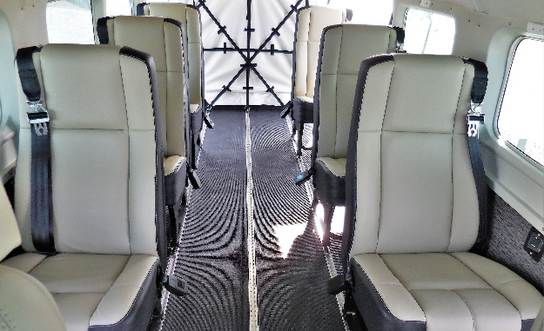
- Garmin SafeTaxi
- Integrated VFR Sectional Charts
- Cabin PA System
- KN-63 DME
- KR 87 ADF Displayed on PFD with Standalone Control
- Garmin Surface Watch
- Garmin GWX 70-4 Color Digital Weather Radar
- Garmin GTS825 Traffic Advisory System
- Garmin TAWS-B
- C406-N 3 Frequency ELT
- Garmin Synthetic Vision Technology
- Garmin GDL-69A SXM (subscription required)

ADDITIONAL EQUIPMENT
- 300 amp starter generator
- Air conditioning system
- 13 Port Oxygen System
- TKS Anti-Ice System (FIKI)
- 29” tires

