Flint Tip Tanks! ADS-B In/Out!
2005 Cessna T206H Turbo Stationair with G1000
N208FT Ser#T20608573

973 Total Time Since New

Avionics:
GMA-1347 Digital Audio Panel with Marker Beacon/Intercom
GTX-345R Transponder with ADS-B In/Out
GIA-63 NAV/COM/GPS with Glideslope #1
GIA-63 NAV/COM/GPS with Glideslope #2
GDU-1040 Primary Flight Display (PFD)
GDU-1040 Multi-function Display (MFD)
GEA-71 Engine/Airframe Computer
GRS-77 AHRS
GDC-74 Air Data Computer with OAT Probe
• CHT/EGT Sensors - All Cylinders
• Fuel Flow Meter
• TIT Sensor
• Manifold/Tachometer/Vacuum Sensors
GMU-44 Magnetometer
KAP-140 Dual Axis Autopilot with Altitude Preselect/GPS Roll Steering
KCM-100 Configuration Module
KS-270C Pitch Axis Servo Actuator
KS-271C Roll Axis Servo Actuator
KS-272C Pitch Trim Servo Actuator
Pilot Control Wheel - Pitch Trim Switch / Autopilot Disconnect
3000-11 Emergency Locator Transmitter
Emergency Locator Transmitter Remote Mounted Switch
WX-500 Stormscope
Control Wheel Push-To-Talk Switch - Pilot/Copilot
Mic & Phone Jacks - Pilot/Copilot/Passengers
Auxiliary Stereo Input Jack
Deck Skin Cooling Fan #1 - Instrument Panel
Avionics Cooling Fan #2 - PFD
Avionics Cooling Fan #3 - MFD
Aft Avionics Cooling Fan #4 - Avionics Equipment
LED Lighted Switch Panel
LED Light Circuit Breaker Panel
Blind Turn Coordinator for KAP-140 Roll Rate Data
Backup Single Pump Vacuum System - Dry
Standby Battery Controller
Standby Battery, 24 volt 6.2 AH
Backup Attitude Gyro, Airspeed & Altimeter Indicator
GDL69A XM Satellite Data / Radio Receiver
AmSafe Inflatable Seat Belts & Shoulder Harness STC, Inertia Reel, Pilot/Co-Pilot/Passenger Seats 3 & 4

Additional Equipment:
Flint Tip Tanks
ADS-B In/Out
Float Kit
Stabilizer Abrasion Boots
Rosen Visors
Hot Prop
Built In Oxygen

Exterior:
Matterhorn White with Ward Red and Pumice Metallic Painted Stripes

Interior:
Leather Seat Surfaces: Mink Leather with Perforated Mink Leather Insert / Mink Vinyl
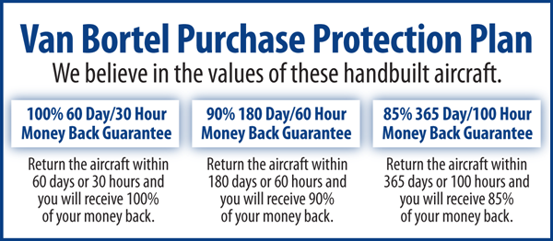

We fly the aircraft to your ramp for inspection by you and your mechanic at no cost or obligation to you.

All Specifications Subject To Verification Upon Inspection

Trades Welcome • No Damage History • Always Hangared • No Corrosion

