Air Conditioned G1000 Turbo 206 – ADS-B IN/OUT – Fresh Annual

STATUS
- Total time, airframe: 689 hours TTSN
- Engine: 689 hours SNEW
- Propeller: 455 hours SMOH
- Annual: June 2020
- Minor hangar damage – replaced with new parts (see salesman for details)

EXTERIOR/INTERIOR
- Exterior trim: Matterhorn White with Electric Red Pearl and Slate Grey stripes
- Interior: tan leather seats with coordinated vinyl side panels

AVIONICS
- Garmin G1000 Integrated Glass Cockpit
- Garmin Primary Flight Display and Multifunction Display
- Dual Garmin GIA 63W WAAS Comm/Nav/GPS
- Garmin Synthetic Vision
- Garmin GDL-69A XM Satellite Weather Depiction
- Garmin GTX 345R ADS-B In/Out Transponder
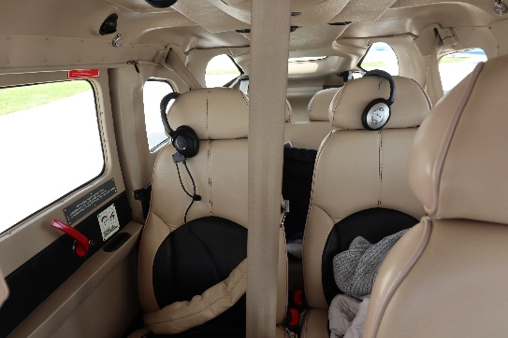
- Solid-state air data computer
- Terrain and obstacle proximity system
- Garmin digital audio panel with digital ATC playback
- Remote transponder indent switch
- Six-place intercom with individual front and rear music outputs

AUTOPILOT
- Garmin GFC 700 Automatic Flight Control System with Flight Director

ADDITIONAL EQUIPMENT
- Three-blade hot propeller
- Reiff engine preheat
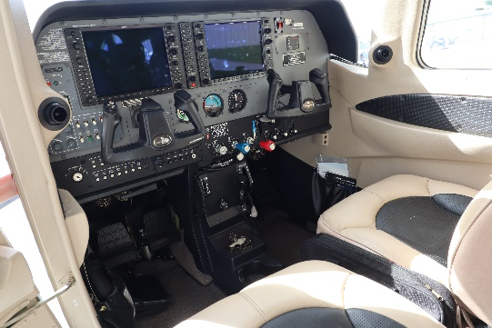
- Built-in oxygen
- Backup battery
- Copilot brakes
- High-speed wheel fairings
- Auxiliary 12V power jack
- Electric trim
- Chronometer clock
- Pilot and copilot sun visors
- Cabin fire extinguisher
- Wing tips and tail strobe lights
- Underwing courtesy light
- Individually reclining rear seat bench
- Soundproofing
- Landing and taxi lights
- Pilot and copilot vertically adjustable seats
- Baggage door with lock and key
- Ground service receptacle
- Refueling steps and handle
- Cargo net
- Tow bar
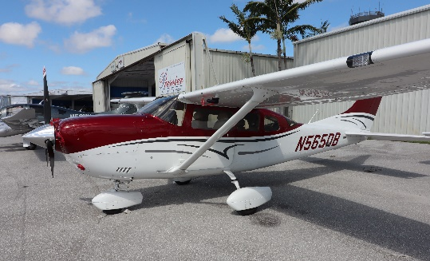
- Kelly electric air conditioning

