WOW “TIME CAPSULE” BEAUTIFUL A36 JAGUAR EDITION BONANZA! ONE OWNER! LOW TIME AIRPLANE AND 350 HOURS SINCE FACTORY NEW ENGINE, WHIRLWIND TURBONORMALIZED
GARMIN GTN 750, GTN 650, GARMIN 500, GARMIN ADS B IN/OUT, KFC 225 AUTOPILOT, TKS

STATUS
- TOTAL TIME, AIRFRAME: 2,075 HOURS
- ENGINE: 375 HOURS SINCE FACTORY NEW ENGINE
- 345 HOURS SINCE OVERHAULED WHIRLWIND TURBO NORMALIZED SYSTEM WITH GAMI INJECTORS
- PROPELLER: 375 HOURS SINCE NEW MT PROP
- ANNUAL: FEBRUARY 2019 BY KALAMAZOO AIRCRAFT
– A BONANZA SPECIALIST

EXTERIOR/INTERIOR
- JAGUAR SPECIAL EDITION WITH CUSTOM GRAPHICS – CHEVRON WHITE WITH GOLD METALLIC AND JADE MIST GREEN ACCENTS
- SPECIAL JAGUAR EDITION CUSTOM CASTLE TAN LEATHER INTERIOR
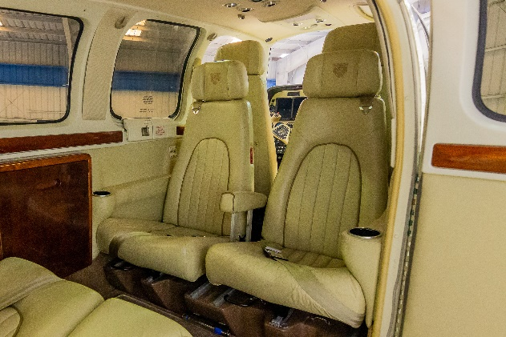
- LEATHER COVERED YOKES AND SPECIAL SEAT TAILORING AND MORE!
- COPILOT VENT WINDOW
- LIKE-NEW GLASS!

AVIONICS
- GARMIN GTN-750 GPS/COM/NAV/WAAS
- GARMIN GTN-650 GPS/COMM/NAV/WAAS
- GARMIN G500 ELECTRONIC FLIGHT DISPLAY
- GARMIN GDL 88 ADSB IN/OUT
- GARMIN GAD 43 AHARS
- GARMIN FLIGHTSTREAM 210 TRANSCEIVER
- PS ENGINEERING PMA 700M-S AUDIO PANEL
- MID-CONTINENT ELECTRIC BACKUP ATTITUDE INDICATOR
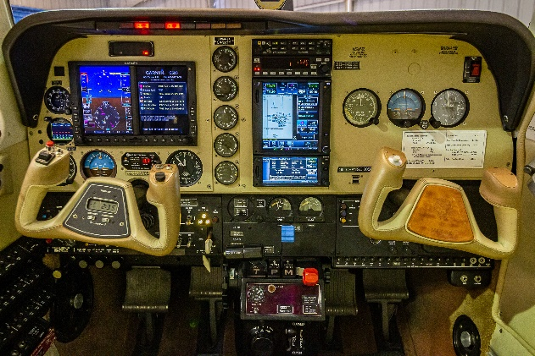
- WX-500 STORMSCOPE
- ARTEX 406 ELT

AUTOPILOT
- KING KFC 225 3-AXIS AUTOPILOT WITH YAW DAMPER

ADDITIONAL EQUIPMENT
- BUILT IN OXYGEN
- TKS ANTI-ICE SYSTEM
- GEM 610 ENGINE MONITOR
- USEFUL LOAD 1404 POUNDS
- TWO USB CHARGING PORTS
- D’SHANNON COOLING BAFFLES
- STANDBY B AND C ALTERNATOR

