One owner, low-time Ovation with two years of warranty remaining.

Gorgeous paint and interior design!

STATUS

Airframe, total time: 100 hours
- Engine: 100 hours
- Propeller: 100 hours
- Annual: April 2020

PERFORMANCE

Max cruise: 197 KTAS

Rate of climb: 1,300 fpm at sea level and max weight

Max range (standard tanks): 1,800 nm (102 U.S. gallons)

Max range (long-range tanks): 2,400 nm (130 U.S. gallons)

Max operating altitude: 20,000 feet

Take-off roll: 1,380 (sea level, max weight)

ENGINE
- Continental IO-550-G, 310 HP
gold standard engine with three-year warranty (parts and labor)

PROPELLER
- Hartzell three-blade constant speed

EXTERIOR/INTERIOR
- Exterior trim: Snow White, Blue Breeze Pearl and Silver Illusion Pearl striping
- Interior: all gray leather interior with black accents and carpet
- Executive interior with tinted aft windows
- AmSafe seatbelts: pilot and copilot

AVIONICS
- Garmin NXI integrated avionics with Jepp charts and SafeTaxi™
- Dual WAAS GPS approach and enroute
- Synthetic vision
- Terrain warning
- GDL69A SXM radio and weather
- Flight Stream 510 – Bluetooth to iPads
- MFD charts — on-screen IFR/VFR charts
- Vertical nav enroute and approach
- GFC 700 digital approach couple autopilot with FD
- GDU 1054, 10” Primary Flight Display, three-axis flight dynamics, air speed, altitude, VS, HSI with perspective modes
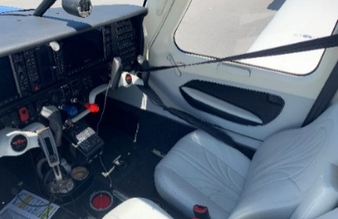
- GDU 1054, 10” Multi-Function Display
- GDC 72 Integrated Digital Air Data Computer, constant display of TAS CAS, wind direction, VSI and TAT
- GRS 79 Solid-State Attitude and Heading Reference System
- Dual GIA63W, integrated radio modules with IFR-approved WAAS GPS, VHF navigation with ILS and VHF communication with 16-watt 8.33-KHZ transceivers
- GMA 1347 Digital Audio Controller with integrated marker beacon and intercom
- GTX 345R Integrated Mode-S Transponder with traffic and WX info service and ADS-B in and out
- GEA 71 Airframe/Engine Interface Unit
- GMU 44 Magnetometer
- Artex ME406 ELT
- Stand-by instrumentation: mid-continent SAM-MD302 two-inch standby attitude module, compass with emergency lighting
- Bose headsets series A20 – pilot and copilot
STANDARD AIRFRAME OPTIONS
- Redundant dual dc electrical bus
- Dual alternators and batteries
- 1.5-inch rudder pedal extensions
- Xenon landing and taxi lights
- Standby alternator, dual bus system
ADDITIONAL EQUIPMENT
- Air conditioning
- Precise Flight Oxygen System (77.1 cubic foot)

