2019 Tecnam P2006T with low hours, excellent fuel efficiency and ready to fly!

STATUS
- Airframe, total time: 64 hours
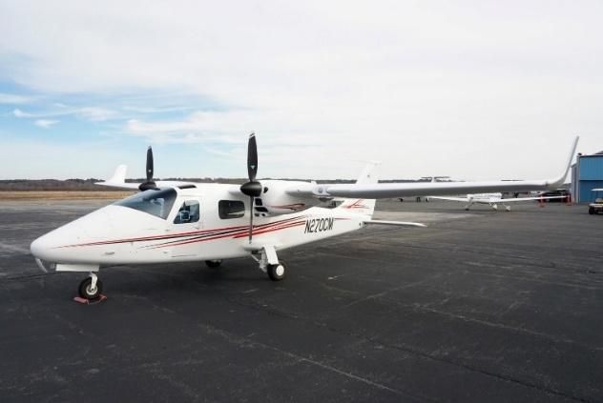
- Left engine: 64 hours
- Right engine: 64 hours
- Left propeller: 64 hours
- Right propeller: 64 hours
- Annual completed: May 2019
- Two-year factory warranty (transferable)

ENGINES
- 2x Rotax 912s3

PROPELLERS
- 2x MT 2-Bladed Constant Speed

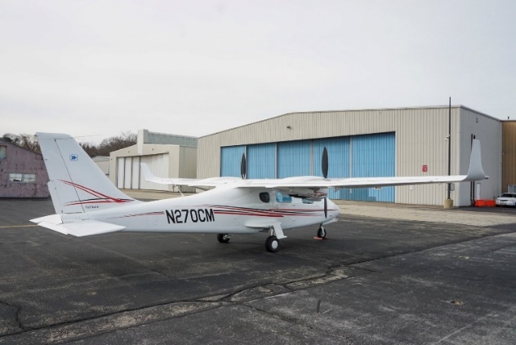
EXTERIOR/INTERIOR
- Exterior: White with red and black accent stripes
- Interior: Premium gray leather seats

AVIONICS
- Avionics/Radios G950NXi Avionics Package includes:
  - GDU 1050 10-inch PFD
  - GDU 1054 10-inch MFD
  - Dual GIA 63W GPS/NAV Receiver/Com Transceiver
  - GMU44 Magnetometer
  - GDC72 Air Data Computer
  - GMA1347 Audio Panel and Marker Receiver
  - GEA 71 Engine and Airframe unit
  - GTX345R Mode S Transponder (ADS-B In and Out)
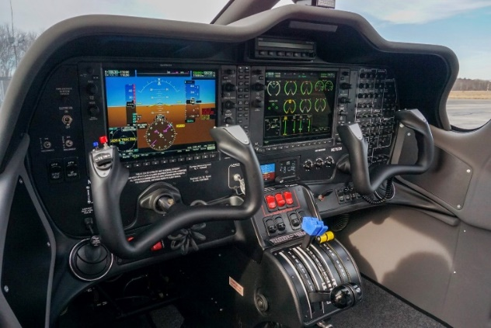
  - ELT 406 MHz
  - Standby Attitude Module (MD-302 SAM)

AUTOPILOT
- S-TEC 55x Dual-Axis Autopilot with Electric Trim

ADDITIONAL EQUIPMENT
- Tow bar
- Surround view windows
- Premium interior
- First aid kit, fire extinguisher

