1979 Cessna Cutlass RG 172RG
N425DL Ser#172RG0143

3778 Total Time Since New
198 Since Major Overhaul by Penn Yan Aero (2017)

Avionics/Equipment:
King KMA-24 TSO Audio Panel
King KX-155 Nav/Com
ARC RT-385A Nav/Com
Dual VOR/LOC with Glideslope
King KT-76A Transponder
PS Engineering PM1000 II Intercom
Cessna 300A Navomatic Autopilot
Narco 190 TSO DME
ARC R-546E 300 ADF
ACK ELT 406/121.5 MHz

Exterior:
Allover White with Dark Blue and Gray Accent Stripes

Interior:
Grey Crushed Velvet

Price: $119,500

$1,110 Per Month
$23,900 Down Payment, Balance of
$95,600 10 Yr. Simple Interest Loan, 6.99%
Fixed for 10 yrs. No Prepayment Penalty

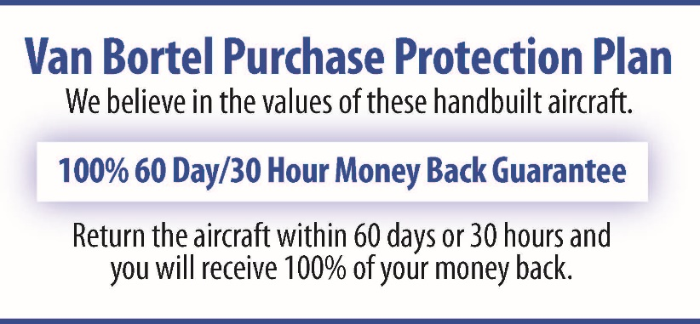

All Specifications Subject To Verification Upon Inspection

