PRIDE OF OWNERSHIP SHOWS • STELLAR COSMETICS INSIDE/OUT! • WHIRLWIND TURBO NORMALIZING SYSTEM GROSS WEIGHT INCREASE • AIR-CONDITIONED • ADS-B IN/OUT • ALWAYS HANGARED • TIP TANKS
ALWAYS BEECH MAINTAINED • IF YOU ARE LOOKING FOR A PREMIER G36, YOU NEED TO SEE THIS ONE!

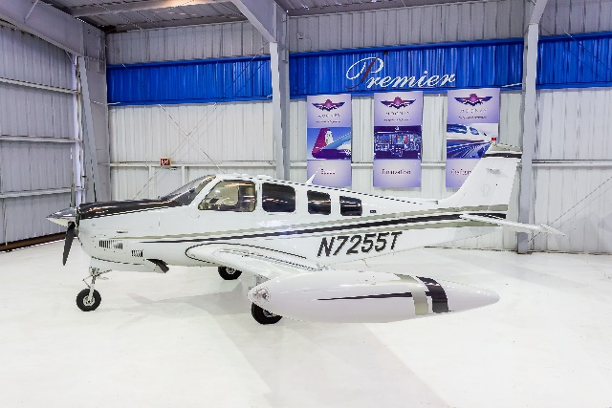
STATUS
- TOTAL TIME, AIRFRAME: 2,150 HOURS SINCE NEW!
- ENGINE: 440 HOURS SINCE OVERHAUL – CONTINENTAL IO-550 B
- 440 HOURS SINCE TURBO NORMALIZING SYSTEM OVERHAUL
- PROPELLER: ONLY 10 HOURS SINCE OVERHAUL
- UPGRADED 4,000 LBS. MAX RAMP WEIGHT AND USEFUL LOAD INCREASE TO 1,241 LBS. (1,275 LBS. WITH TWO AFT SEATS REMOVED)
- ANNUAL COMPLETED: FEBRUARY 2019
- NO KNOWN DAMAGE HISTORY

EXTERIOR/INTERIOR
- OVERALL DESOTO WHITE WITH PEPPER GRAY METALLIC AND METALLIC BLACK ACCENTS
- TAN LEATHER - WITH CHOCOLATE BROWN CARPETING

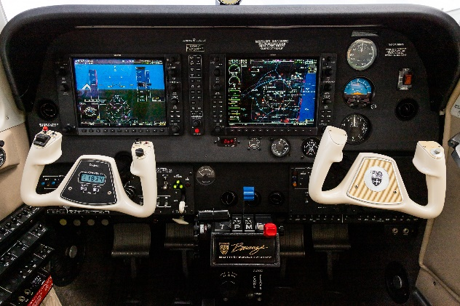
AVIONICS – G1000 WITH WAAS UPGRADE!
- GARMIN G1000 INTEGRATED FLIGHT DECK
- DUAL GARMIN GIA63W, WAAS COMM/NAV/GPS
- GARMIN GDL69A SATELLITE DATA LINK WEATHER
- UPGRADED GARMIN XM REMOTE CONTROL MUSIC SELECTOR
- GARMIN GTX 345R TRANSPONDER ADS-B IN AND OUT
- GARMIN TAWS-B TERRAIN AWARENESS AND WARNING SYSTEM
- L3 SKYWATCH 497 ACTIVE TRAFFIC SYSTEM
- SYNTHETIC VISION
- SIX BOSE POWER PLUGS
- JEPPVIEW CHART VIEWER
- GARMIN SAFETAXI

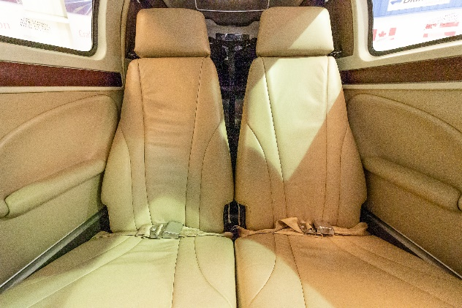
AUTOPILOT
- GARMIN GFC700 3-AXIS INTEGRATED FLIGHT CONTROL SYSTEM
- YAW DAMPER
- ALTITUDE PRE-SELECT AND VNAV APPROACH COUPLING

ADDITIONAL EQUIPMENT
- DUAL ALTERNATORS
- ELECTRIC STAND BY GYRO
- SUPER SOUNDPROOFING
- FACTORY AIR CONDITIONING
- PROP DE-ICE
- G AND D WINDOW INSERTS WITH DARK TINT
- COPILOT BRAKES
- HOT PROP
- GAMI INJECTORS
- BUILT-IN OXYGEN

