ADS-B In/Out!
2004 Cessna T206H Turbo Stationair with G1000
N206L Ser#T20608498

1662 Total Time Since New
181 Since Major Overhaul by Victor Aviation (New Limits)

Avionics:
GMA-1347 Digital Audio Panel with Marker Beacon/Intercom
GTX-345R Transponder with ADS-B In/Out
GIA-63 NAV/COM/GPS with Glideslope #1
GIA-63 NAV/COM/GPS with Glideslope #2
CI-2480 VHF/GPS Antenna with Internal Notch Filter #1
CI-2480 VHF/GPS Antenna with Internal Notch Filter #2
GDU-1040 Primary Flight Display (PFD)
GDU-1040 Multi-function Display (MFD)
GEA-71 Engine/Airframe Computer
GRS-77 AHRS
GDC-74 Air Data Computer with OAT Probe
GMU-44 Magnetometer
KAP-140 Dual Axis Autopilot with Altitude Preselect
KCM-100 Configuration Module
KS-270C Pitch Axis Servo Actuator
KS-271C Roll Axis Servo Actuator
KS-272C Pitch Trim Servo Actuator
Pilot Control Wheel - Pitch Trim Switch / Autopilot Disconnect
3000-11 Emergency Locator Transmitter
WX-500 Stormscope
NY-163 Stormscope Antenna
Control Wheel Push-To-Talk Switch - Pilot/Copilot
Mic & Phone Jacks - Pilot/Copilot/Passengers
Auxiliary Stereo Input Jack
Avionics Cooling Fan #1 - Instrument Panel
Avionics Cooling Fan #2 - PFD
Avionics Cooling Fan #3 - MFD
Avionics Cooling Fan #4 - Avionics Equipment
Lighted Switch/Circuit Breaker (Pullable) Panel
Blind Turn Coordinator for KAP-140 Roll Rate Data
Backup Single Pump Vacuum System - Dry
Standby Battery, 24 volt 8 AH
Backup Attitude Gyro, Airspeed & Altimeter Indicator
GDL-69A XM Satellite Data / Radio Receiver

Additional Equipment:
ADS-B In/Out
Stabilizer Boots
Float Kit
Hot Prop
Built In Oxygen

Exterior:
Matterhorn White with Titanium Metallic Painted Stripes; Balboa Blue Painted Cowling and Tail Stripes.

Interior:
Leather Seat Surfaces, Mink Leather with Perforated Mink Leather Insert / Mink Vinyl

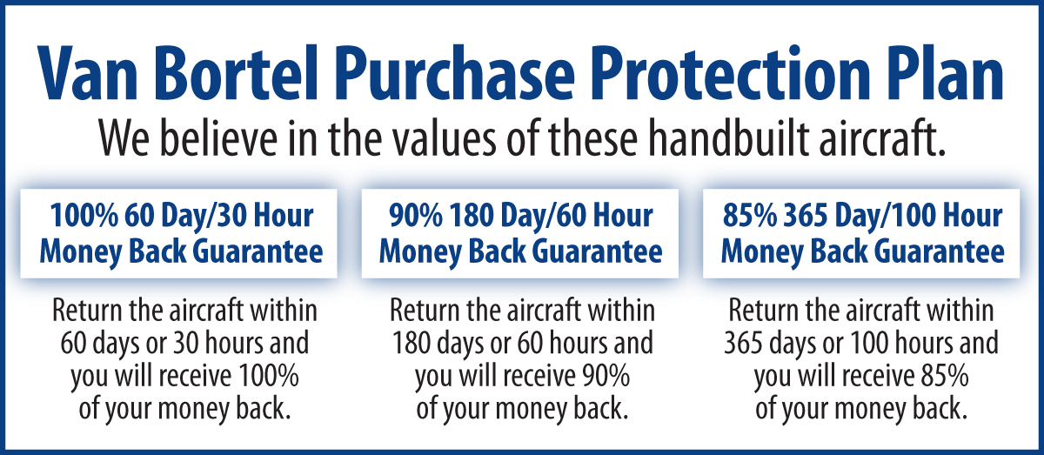

We fly the aircraft to your ramp for inspection by you and your mechanic at no cost or obligation to you.

All Specifications Subject To Verification Upon Inspection

Trades Welcome • No Damage History • Always Hangared • No Corrosion

