LOW TIME DA42 2.0 TDI WITH 2,100 HOUR TBR ENGINES, APRIL 2020 DIAMOND SERVICE CENTER ANNUAL, ADS-B OUT EQUIPPED, NO DAMAGE HISTORY

STATUS
- Total time, airframe: 1,207 hours (subject to change)
- Engines: 623 hours SNEW (2,100 hours TBR)
- Right Propeller: 758 SPOH
- Left Propeller: 47 hours SPOH
- Annual: April 2020 by Diamond Authorized Service Center
- No damage history

EXTERIOR/INTERIOR
- Exterior trim: White with chameleon and gold stripes and registration number
- Interior: Tan leather interior

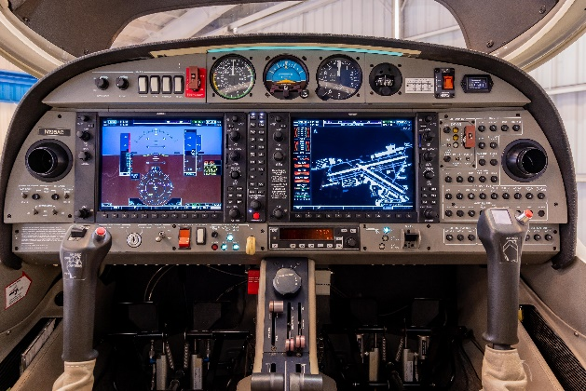
AVIONICS
- Standard package with Garmin G1000
- GDU1040, 10-inch Primary Flight Display
- GDU1040, 10-inch Multi-Function Display
- Garmin Integrated VFR Terrain Awareness System
- Remote Avionics Mounting Rack w/ Line Replaceable Units
- GEA71 Airframe/Engine Interface Unit
- Dual Garmin GIA 63 COM/NAV/GPS
- GMA1347 Digital Audio System
- GRS77 Solid-state Attitude Heading Reference System
- GDC74 Digital Air Data Computer
- GMU44 Magnetometer
- Standby instruments
- ELT Artex 406 MHz
- GTX 335R ADS-B OUT

AUTOPILOT
- Honeywell KAP140 Dual Axis Autopilot with Altitude Hold and Preselect

ADDITIONAL EQUIPMENT
- Composite cabin and safety seats (up to 26g)
- Lightning protection system
- Fire extinguisher
- FAILSAFE Airframe Design
- 3-point safety belts automatic (all seats)
- Power supply socket for handheld GPS
- Hydraulic retractable landing gear
- High intensity discharge landing and taxi lights
- Position and anti-collision lights
- 4-way baggage compartment system
- Nose baggage compartment accessible from both sides
- Long Range Fuel Tanks– (79 Gallons)
- TKS Deicing System

