FULLY LOADED WITH WAAS, AIR CONDITIONIG, SYNTHETIC VISION,
AND THE SOUGHT-AFTER GARMIN GFC 700 AUTOPILOT! 310 HP!
METICULOUSLY MAINTAINED BY MOONEY SERVICE CENTER!

STATUS
- AIRFRAME: 1,250 HOURS SINCE NEW
- ENGINE: 1,250 HOURS SINCE NEW
- PROPELLER: 941 SINCE NEW
- ANNUAL DUE MAY 2019
- DAMAGE HISTORY—DETAILS AVAILABLE

EXTERIOR/INTERIOR
- MING BLUE WITH GOLD ACCENT STRIPES
- TAN LEATHER INTERIOR

AVIONICS
- GARMIN GDU 1040, 10” PRIMARY FLIGHT DISPLAY, THREE AXIS FLIGHT DYNAMICS, AIRSPEED, ALTITUDE, VERTICAL SPEED, HSI WITH PERSPECTIVE MODES
- GARMIN GDU 1040, 10” MULTI-FUNCTION DISPLAY
- GARMIN GDC 74A INTEGRATED DIGITAL AIR DATA COMPUTER
- GRS77 SOLID-STATE ATTITUDE AND HEADING REFERENCE SYSTEM
- DUAL GARMIN GIA63, INTEGRATED RADIO MODULES WITH IFR APPROVED GPS, VHF NAVIGATION WITH ILS AND VHF COMMUNICATION
- GMA 1347 AUDIO PANEL WITH MARKER BEACON AND INTERCOM
- GARMIN GTX 330 TRANSPONDER
- WAAS UPGRADE
- GARMIN SYNTHETIC VISION
- GARMIN GEA 71 AIRFRAME/ENGINE INTERFACE UNIT
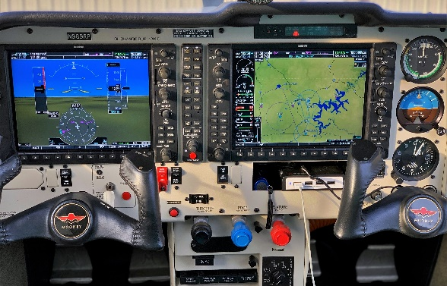
- GARMIN GMU 44 MAGNETOMETER
- STANDBY INSTRUMENTATION, INCLUDING ADI, A/S, ALTIMETER AND MAGNETIC DIRECTION INDICATOR WITH EMERGENCY LIGHTING
- GARMIN GDL 69A SATELLITE DATA LINK—NEXRAD WEATHER AND AUDIO INFOTAINMENT (SUBSCRIPTIONS REQUIRED)
- INSTALLATION OF HOT-WIRE PLUGS FOR BOSE (PILOT AND COPILOT)
- GARMIN SAFETAXI AND FLITECHARTS (SUBSCRIPTION REQUIRED)

AUTOPILOT
- GFC 700 FULLY INTEGRATED DIGITAL AUTOPILOT WITH FLIGHT DIRECTOR

ADDITIONAL EQUIPMENT
- AMSAFE SEATBELTS
- OXYGEN SYSTEM (115 CUBIC FEET)
- AIR CONDITIONING
