2000 CESSNA CITATION X
N194SR – SN 750-0112
Price: Inquire – TRADES CONSIDERED!

WANT TO GO FAST AND IN STYLE? THIS EXCEPTIONALLY MAINTAINED AND CARED FOR CITATION X WILL TAKE YOU TO THE EDGE OF THE SOUND BARRIER LIKE NO OTHER AIRCRAFT ON THE MARKET!

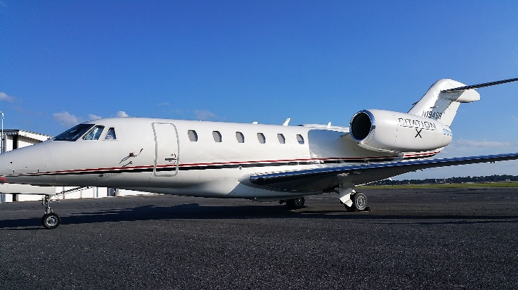
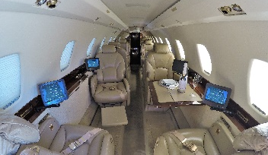
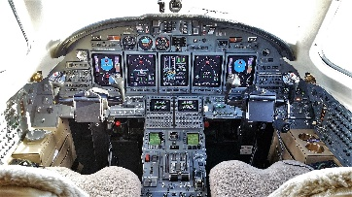

STATUS
TOTAL TIME: AIRFRAME: 5,040 HOURS SINCE NEW
CYCLES: 2,820
APU HOURS: 2,990 HOURS
PASSENGER SEATING: 8
FRESH ENGINE OVERHAULS BY ROLLS-ROYCE

EXTERIOR
ALL OVER WHITE WITH BLACK AND RED ACCENT STRIPES

INTERIOR
EXECUTIVE CONFIGURATION WITH FORWARD AND AFT CLUB SEATING FOR 8 PASSENGERS, EACH WITH AN ENTERTAINMENT CONTROL
FORWARD 10” CABIN DISPLAY WITH AIRSHOW 4000, AND TWO (2) 8” INDIVIDUAL MONITORS
DUAL (2) DVD/CD PLAYERS
FORWARD GALLEY WITH A MICROWAVE OVEN, COFFEE MAKER AND ESPRESSO MACHINE

AVIONICS
HONEYWELL PRIMUS 2000 WITH 5 TUBE EFIS
ADF: HONEYWELL RNZ-850
AFIS: SATAFIS
COMMUNICATION RADIOS: DUAL HONEYWELL RCZ-833 WITH 8.33 SPACING
NAVIGATION RADIOS: DUAL HONEYWELL RNZ-850 WITH FM IMMUNITY
CVR: FAIRCHILD FA2100
DUAL DME
FMS: DUAL HONEYWELL FMZ-2000 WITH DUAL GPS
HF: DUAL HONEYWELL KHF-950 WITH COLTECH CSD-714 SELCAL
IRS: DUAL HONEYWELL LASEREF IV
RADAR ALTIMETER: HONEYWELL AA-300
SATCOM: AIRCELL AXXESS II IRIDIUM
TAWS: HONEYWELL MARK V EGPWS
TCAS: HONEYWELL TCAS-2000 TCAS II WITH CHANGE 7
TRANSPONDER WITH ENHANCED SURVEILLANCE
WEATHER RADAR: HONEYWELL PRIMUS 880

AUTOPILOT
HONEYWELL PRIMUS 2000 IFCS

ACCESSORY EQUIPMENT
DUAL OXYGEN BOTTLES (EXTENDED RANGE O2)
SINGLE-POINT REFUELING
LEAD ACID BATTERIES
TERRAIN AWARENESS AND WARNING SYSTEM (TAWS)
TRAFFIC COLLISION AVOIDANCE SYSTEM (TCAS II)
SATCOM
COCKPIT VOICE RECORDER (CVR)
8.33 CHANNEL SPACING

MAINTENANCE PROGRAMS
ENGINES ENROLLED ON ROLLS-ROYCE CORPORATE CARE (RRCC)
AIRFRAME ON CESSNA PRO-PARTS
MAINTENANCE TRACKED BY CESSCOM (CAMP)

