2016 Garmin G1000 Cessna T206H Turbo Stationair |  |  |  |  |  | N721WW Serial Number T20609222
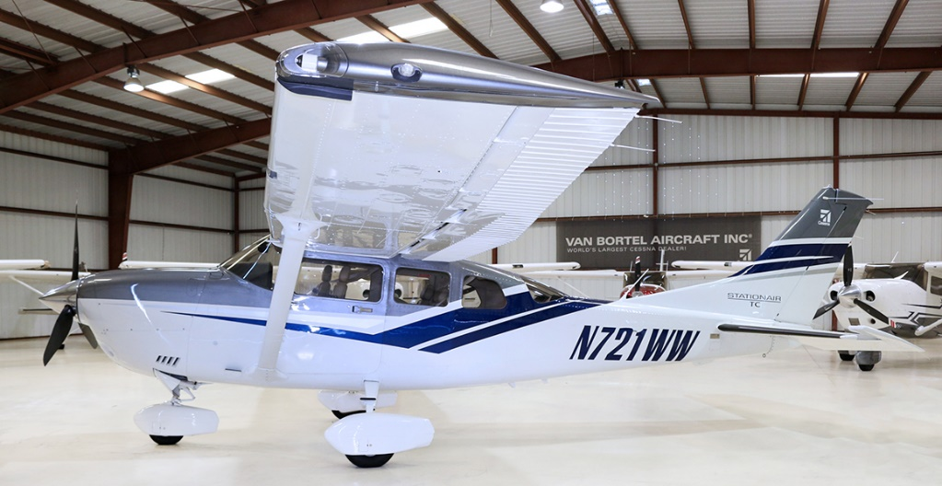
301 Total Time
 |  |  |  |  | Luxor II Leather Seats
Exterior: |  |  |  |  | 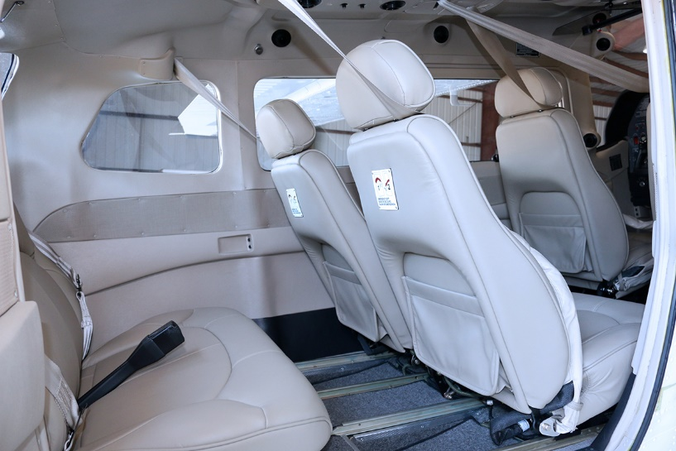
Cumulus/Silver/Medium Concord Blue
Wheel Fairings
Float Plane Provisions
Stabilizer Boots
Interior:
Luxor II Leather Seats
Avionics:
Garmin GTS800 Traffic Advisory System (TAS)
Garmin GDL69A XM Weather & Radio
Garmin GTX 33 ADS-B Out
Garmin Synthetic Vision Technology (SVT)
 |  |  |  |  | Standard Avionics Features - Garmin G1000
 |  |  |  |  | GMA-1347 Digital Audio Panel with Marker Beacon/Intercom  GTX-33 Transponder-Mode S w-TIS  GIA-63W NAV/COM/GPS/WAAS with GS #1  GIA-63W NAV/COM/GPS/WAAS with GS #2  GDU-1044B Primary Flight Display (PFD)  GDU-1044B Multi-Function Display (MFD)  GEA-71 Engine/Airframe Computer  GRS-77 Attitude & Heading Reference System (AHRS)  GDC-74A Air Data Computer with OAT Probe  GMU-44 Magnetometer  Garmin SafeTaxi & FliteCharts  GFC-700 Autopilot  Go-Around Switch  Electric Trim  A/P Disconnect  Control Wheel Steering Button  Electronic Checklists |  | ME406 Two Frequency Emergency Locator Transmitter  Emergency Locator Transmitter Remote Mounted Switch  Backup Attitude Gyro, Altimeter and Airspeed Indicator  Control Wheel Push-To-Talk Switch-Pilot/Copilot  Mic & Phone Jacks-Pilot/Copilot/Passengers  Auxiliary Stereo Input Jack  Antennas:  • Marker Beacon Antenna  • Transponder Antenna  • VHF/GPS Antenna (2)  • NAV Antenna  • Emergency Locator Transmitter External Antenna  Pitot System - Heated  Static System  Hand Held Microphone  Alternate Static Source  Compass

