Newest and lowest time M600 on the market—three years of warranty remaining on airframe and avionics and five years on engine! Like-new inside and out! SVT, Awareness Package, Weather Package, ADS-B, air conditioning! You must see this one! Sale includes new annual inspection and Premier Training Package. Trades welcome and great financing available.

STATUS
- Total time, airframe, prop and engine: 371 hours
- No damage history
- New annual with sale
- Remaining warranty until February of 2023 on airframe, avionics and prop and February of 2025 on engine
- Flawless condition, always hangared

EXTERIOR/INTERIOR
- Exterior trim: Sykes White over Fighter Blue with Gloss Black and Fighter Blue stripes
- Interior: Light tan leather seats with dark brown side panels
- Rich Burl wood table and side panel accents
- Relief tube
- Rosen Sun Visors

AVIONICS
- Garmin G3000 Avionics Suite:
- Enhanced AFCS
- Synthetic Vision
- Dual 12.1” PFDs
- Single 12.1” MFD
- Dual GTC 570 Touchscreen Cockpit Management Units
- Dual GIA 63W Nav/Com/GPS (WAAS enabled)
- GEA 71 Engine and Airframe Interface
- GMC 710 AP Controller
- Dual GMU Magnetometer Units
- Dual GRS 77 AHRS Computers
- GMA 36 Digital Audio Panel
- Dual GDC 74 Air Data Computers
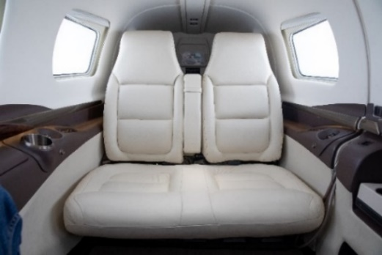
- Dual GTX 33 ES Mode S Transponder (ADS-B out
compliant)
- GAE 43 Altitude Encoder
- GWX 70 All Digital Weather Radar
- Garmin SafeTaxi
- Aspen EFD 1000 Standby Flight Instruments
- Integrated Digital Cabin Pressurization
- FlightStream 110

AUTOPILOT
- GFC 700 Autopilot with enhanced AFCS and yaw damper

ADDITIONAL EQUIPMENT
- Awareness package (included):
- Option 150 – SurfaceWatch
- Option 235 – Jeppesen ChartView
- Option 855 – GTS 855 traffic advisory system (TCAS I)
- Option 450 – TAWS-B
- Option 631 – GTX33 ES second transponder

- Weather package (included):
- Option 269 – Garmin GDL-69A XM Radio / Weather
- Option 330 – WX-500 StormScope

ACCESSORY EQUIPMENT
- PiperAire air conditioning
- Flight into known icing (FIKI)
- Three USB charging ports – cockpit and two in cabin
