Everything is Like Brand New Except the Price!
Low Time, Great Maintenance and Dual ADS-B In and Out! • Always Hangared and
Always Professionally Flown • Great Financing Available, Trades Welcome and Training Included

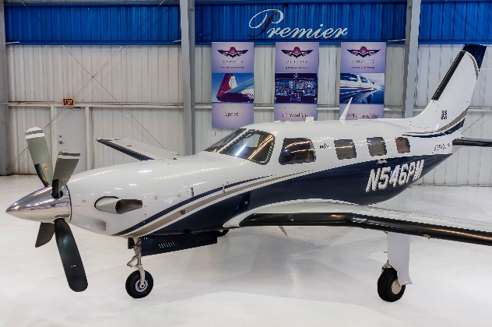
STATUS
- TOTAL TIME, AIRFRAME: ONLY 718 HOURS
- PROPELLER: ONLY 718 HOURS SINCE NEW
  - HARTZELL HC-E4N-3Q
- ENGINE: ONLY 718 HOURS
  - PRATT AND WHITNEY PT6A-42A
  - TBO: 3,600 HOURS
- ANNUAL INSPECTION COMPLETED: OCTOBER ANNUAL—JUNE 100 HOUR AND JUST PASSED OUR PREBUY INSPECTION AND BOROSCOPE
- USEFUL LOAD: 1,680 POUNDS

EXTERIOR/INTERIOR
- SNOW WHITE OVER FLAG BLUE AND PLATINUM PEARL
- TAN LEATHER INTERIOR WITH WOOL CARPETING

AVIONICS
- GARMIN G1000 AVIONICS SUITE WITH WAAS AND SYNTHETIC VISION:
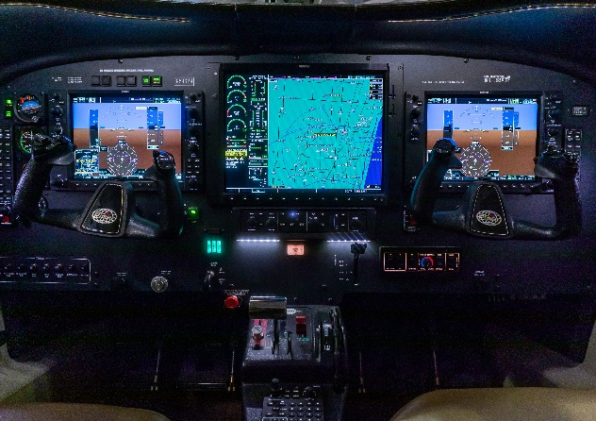
- DUAL GDU 1040A 10” PRIMARY FLIGHT DISPLAY
- 15” MULTI-FUNCTION DISPLAY
- DUAL GMA1347 AUDIO PANELS
- DUAL GDC 74A AIR DATA COMPUTERS
- GARMIN 345R TRANSPONDER WITH ADS-B IN AND OUT
- GARMIN 335R-- SECOND TRANSPONDER WITH ADS-B OUT
- GARMIN GWX 68 COLOR RADAR
- BENDIX KING KTA 870 ACTIVE TRAFFIC SYSTEM
- JEPPESEN CHARTVIEW
- TAWS-B (TERRAIN AWARENESS AND WARNING SYSTEM)
- DUAL GARMIN GRS-77 AHRS
- DUAL GARMIN GMU-44 MAGNETOMETERS
- GDL-69A SATELLITE RADIO/WEATHER DATA RECEIVER
- DIGITAL STANDBY ATTITUDE INDICATOR

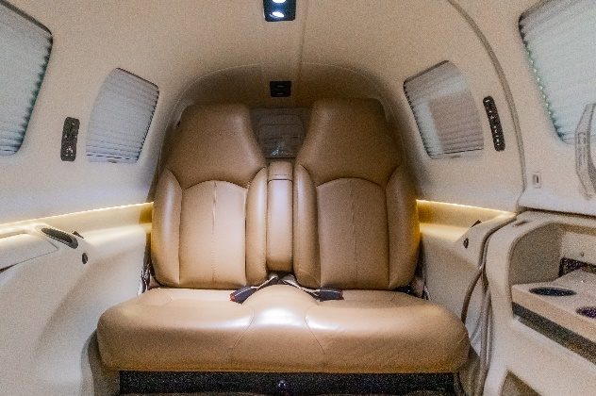
AUTOPILOT

GARMIN GFC 710 AUTOPILOT/FLIGHT DIRECTOR WITH VNAV COUPLING FOR WAAS APPROACHES

ADDITIONAL EQUIPMENT
- KNOWN ICING SYSTEM
- OVERHEAD SWITCH PANEL
- PIPER HFC-134A AIR-CONDITIONING
- H3R HALON FIRE EXTINGUISHER
- SAFE FLIGHT LIFT COMPUTER
- ARTEX ME 406 MHZ ELT
- COMPRESSOR WASH RING
- CREW ALERTER SYSTEM
- STAINLESS STEEL COWLING FASTENERS
- OPTIONAL LED LANDING AND TAXI LIGHTS
- 3-POSITION STROBE LIGHTS
- DUAL ELEVATOR AND RUDDER CONTROLS
- TURBINE INLETS PLUGS
- RELIEF TUBE

