Fully equipped Bell 429 with 3rd EFIS Screen, Autopilot, VIP Interior for 6,

air conditioning, Aux Fuel Tank and much more!

One owner since new. Always maintained at Bell Authorized Service Center. Priced to sell!
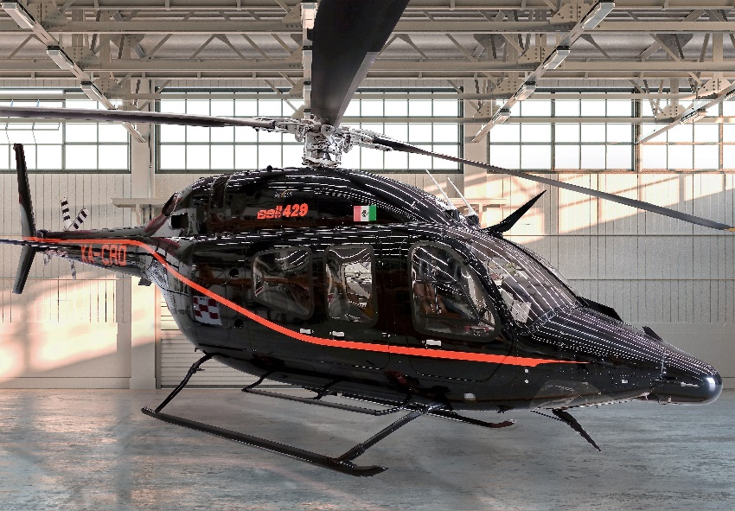

general

Engines, total time: 990 hours
- Engine cycles: 3,375 cycles PW207-D1
- No damage history

EXTERIOR/INTERIOR
- High Gloss Black with One Orange accent stripe
- Black leather corporate interior
- VIP Seating for 6/2 crew
- Air Conditioning

AVIONICS
- 3rd Display Unit
- Garmin GTN 750 NAV/COMM/GPS
- Garmin GTN 650 NAV/COMM/GPS
- 3-Axis Autopilot
- Avidyne TAS605 Traffic Advisory System
- Curtiss Wright CVR/FDR
- ADS-B OUT
- Dual Bell Standby Compass
- Honeywell Radar Altimeter KRA 405B
- Weather Radar Primus 660

INSTALLED EQUIPMENT
- Wire Strike Protection System
- Dual Evaporator Air Conditioning System
- Door Opener Kit & Floor Protector
- Dual Inlet Barrier Filter Installation
- Compressor Wash Kit Installation
- Soundproofing Kit Installation
- Passenger Step-Full Kit Installation
- Auxiliary Fuel Tank (39 US Gal)
- Thermo plastic sidewall closeout
- Dual Controls
MAINTENANCE TRACKING PROGRAM
- CAMP SYSTEMS
- OAT Probe GTP 59

