LOOKING FOR A BRAND NEW G36? HERE IS THE NEXT BEST THING! NEW, IMPROVED STYLE MILLENIUM INTERIOR—NEW HIGHER CAPACITY, REALLY COLD AIR CONDITIONING SYSTEM
ADS-B OUT • ALWAYS HANGARED • IT LOOKS VIRTUALLY BRAND NEW!

STATUS
- TOTAL TIME, AIRFRAME: 669 HOURS
- ENGINE: 669 HOURS
- PROPELLER: 669 HOURS
- ANNUAL COMPLETED: MARCH 2019
- NO KNOWN DAMAGE HISTORY

EXTERIOR/INTERIOR-LIKE NEW!
- OVERALL MATTERHORN WHITE WITH TIBETIAN GOLD METALLIC AND BLACK METALLIC ACCENTS
- TAN LEATHER IN NEW STYLE SEATING AND SIDEPANELS

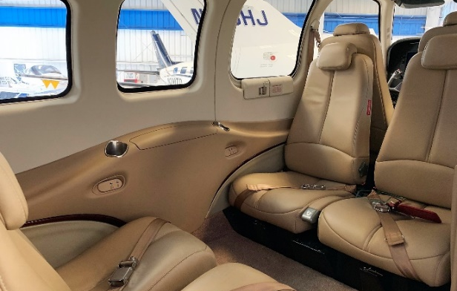
AVIONICS
- GARMIN G1000 INTEGRATED FLIGHT DECK
- DUAL GARMIN GIA63W, WAAS COMM/NAV/GPS
- GARMIN GDL69A SATELLITE DATA LINK WEATHER
- GARMIN GTX 33 ES TRANSPONDER ADS-B OUT CAPABLE
- GARMIN TAWS-B TERRAIN AWARENESS AND WARNING SYSTEM
- GARMIN GTS 820 LONG RANGE ACTIVE TRAFFIC SYSTEM
- SYNTHETIC VISION – SVT
- JEPPVIEW CHART VIEW
- GARMIN SAFETAXI

AUTOPILOT
- GARMIN GFC700 3-AXIS INTEGRATED FLIGHT CONTROL SYSTEM
- YAW DAMPER
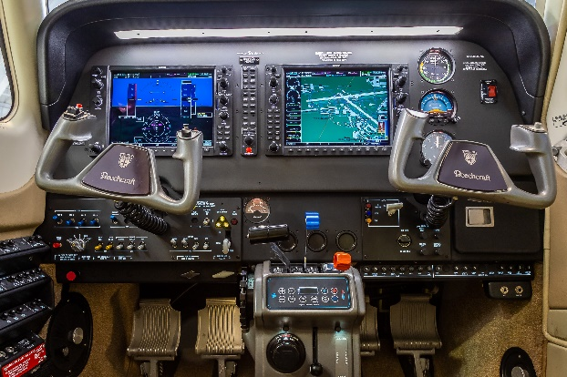
- ALTITUDE PRE-SELECT AND VNAV APPROACH COUPLING

ADDITIONAL EQUIPMENT
- COPILOT BRAKES
- LED LANDING LIGHT
- DUAL ALTERNATORS
- ELECTRIC PROP DE-ICE
- SUPER SOUNDPROOFING
- ELECTRIC STANDBY GYRO
- G AND D WINDOW INSERTS WITH DARK TINT
- LED WINGTIP STROBE AND POSITION LIGHTS
- NEW CURRENT STYLE FACTORY AIR CONDITIONING

