We don’t find trades this nice very often! – fresh engine overhaul -
ADS-B out compliant - always hangared! No damage!
Avidyne glass panel – air conditioned

STATUS
- Total time: Only 1,680 hours since new (subject to change)
- Engine: 0 hours since major overhaul by Certified Engines
- Prop: 720 hours since major overhaul
- No damage history
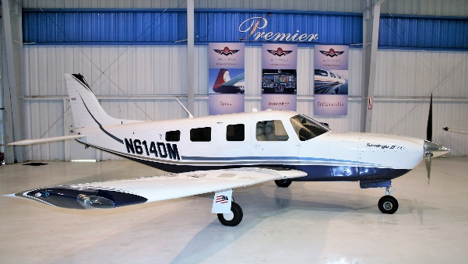
- Annual: August 2019
- Useful load: 1,036 pounds

EXTERIOR/INTERIOR
- Medium concord blue metallic with pumice and blue metallic accents over white
- Light grey deluxe leather interior
- Executive writing desk
- Refreshment console with portable cooler
- Pilot and copilot vertically adjusting seats
- Overhead passenger reading lamps

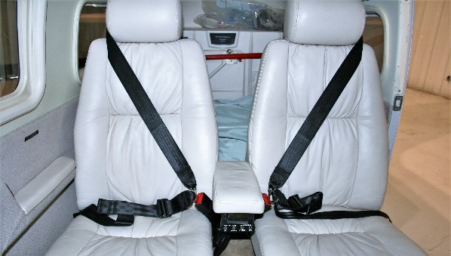
AVIONICS
- Avidyne Flightmax Entegra primary flight display
- Coupled to system 55X with altitude and rate pre-select
- H.S.I / FD, altitude, rate of climb, MAP, RPM, active navigation presentations
- Entegra multifunction flight situation display
- EMAX - engine monitoring, fuel management
- Dual Garmin GNS 430– IFR approach certified GPS/ILS/VOR/LOC/COM
- Garmin GMA-340 audio switching panel with marker beacon
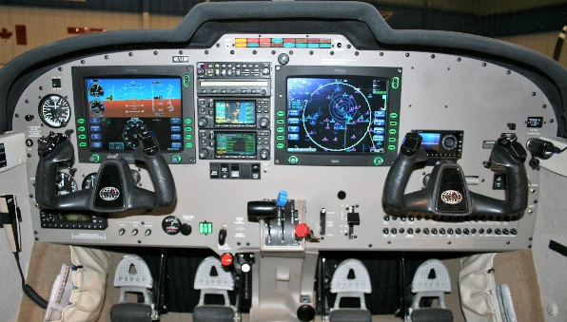
- Stratus ESG ADS-B OUT transponder
- Avidyne TAS600 active traffic system
- L3 WX500 Stormscope
- CMAX approach charts (subscription required)
- Avidyne XM data receiver
- XM Music receiver – portable (subscription required)
- Midcontinent electric standby attitude indicator
- Artex ME406 ELT
- Six place intercom system

AUTOPILOT
- S-TEC System 55X autopilot with flight director and GPSS

ADDITIONAL EQUIPMENT
- PiperAire air conditioning
- Pilot’s Bose powered headset jack
- 6-place oxygen system – 50 cu. Ft.
- Standby battery
- Reiff engine preheater
- External power receptacle

