THIS IS YOUR CHANCE TO OWN A ONE-OF-A-KIND PAINT SCHEME, LOW-TIME, FULLY EQUIPPED DIAMOND DA62 WITH TKS, AIR, 7-PASSENGER INTERIOR AND MUCH MORE

STATUS
- Total time, airframe: 220 hours
- Engines: 220 hours
- Propellers: 220 hours
- Annual: January 2020
- No damage history
EXTERIOR
- Custom one-of-a-kind paint scheme in high-gloss metallic Seminole Red with white and light silver accent stripes
INTERIOR
- Premium black leather interior with pilot and copilot sheepskin seat covers
- Adjustable backrest for pilot and copilot
- Ergonomic seats and backrest
- Fabric inlays
- Electrically operated adjustable rudder pedals
- Sun glare shields and canopy lining
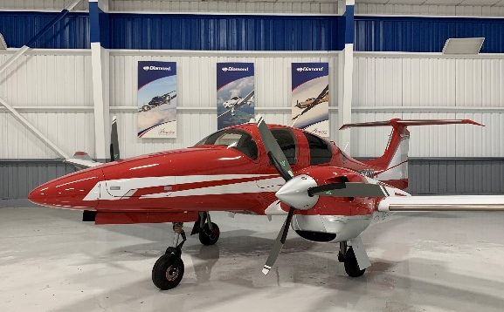
- 28v power supply socket
- Instrument lighting

AVIONICS
- Integrated Garmin G1000 NXi Glass Panel Cockpit, including:
  - 2x Garmin GDU 105X 10-inch Flight Displays (PFD and MFD)
  - Garmin GEA 71 Airframe/Engine Interface Unit
  - 2x Garmin GIA 63 WAAS COM/NAV/GPS/GS/LOC
  - Garmin GMA 1347 Digital Audio System
  - Garmin GRS 79 Attitude Heading Reference System
  - Garmin GDC 72 Digital Air Data Computer
  - Garmin GMU 44 Magnetometer
  - Garmin GFC 700 Automatic Flight Control System with yaw damper
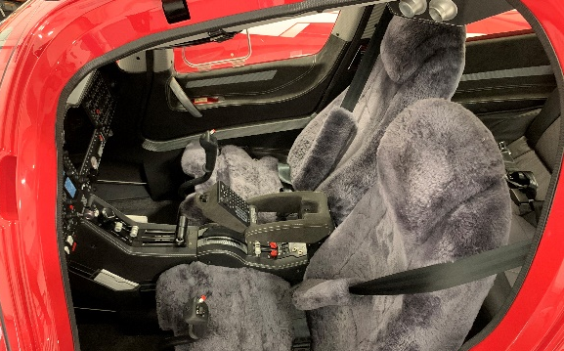
  - Garmin GTX 335 R remote ADS-B transponder (ADS-B in/out)
  - ELT 406 MHz
  - 2nd Digital Standby Attitude Module (MD-302 SAM)
AVIONICS – INSTALLED OPTIONS
- Avidyne TAS 605 Traffic Advisory System
- Garmin GWX 70 Weather Radar
- Garmin GCU 476 Keypad
- Garmin Synthetic Vision Technology
- Garmin GDL 69A SAT WX (subscription required)
- Jeppesen Chartview (subscription required)
ADDITIONAL – INSTALLED OPTIONS
- Air conditioning/RACC II System
- TKS deicing system
- Oxygen system
- 3rd row seating configuration (rear seating for two additional passengers)

SAFETY CONCEPT
- Composite cabin and safety seats
- “FAILSAFE” airframe and wing design
- Multipath Lightning Protection System
- 3-point safety belts automatic (all seats)
- Garmin ESP (Electronic Stability Protection)
OTHER EQUIPMENT
- Nose baggage compartment accessible from both sides
- Tow bar, tool kit, control gust lock
- First aid kit, extinguisher, emergency axe, egress hammer

