New and Improved Bell 407GXP With Increased Power Of 50 SHP;
Exceptional Performance in “Hot and High” Conditions; Improved Fuel Efficiency and Added Safety with The Garmin G1000 NXI Glass Cockpit
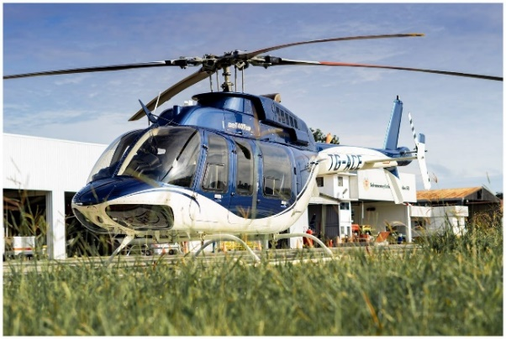

general

Clean and Well-Maintained

Airframe, Total Time1,523 Hours

Engine: 1,485 Hours
- Engine Cycles: CSN 1,988 Cycles
- No Damage History

EXTERIOR/INTERIOR
- Exterior Trim: White and Blue
- Interior: Blue Leather
- VIP Corporate Configuration
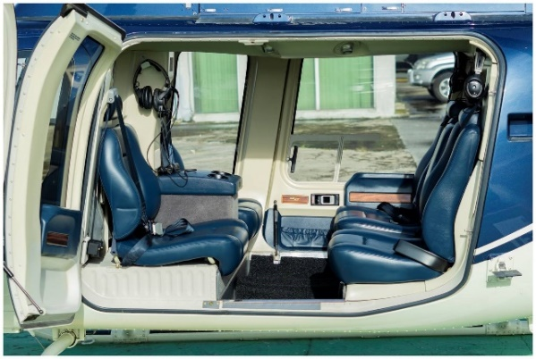
- Air Conditioning

EQUIPMENT/FEATURES
- Glass Cockpit G1000H NXI
- Rubber Mounted Chin Bubbles
- Tail Rotor Camera
- Jettison-Enabled Door
- Battery 28 AMPS
- Dual Controls
- Aux Fuel Tank Provisions (19 Gallons)
- M/R Blade High Visibility
- Wire Strike Protection System
- Rotor Brake
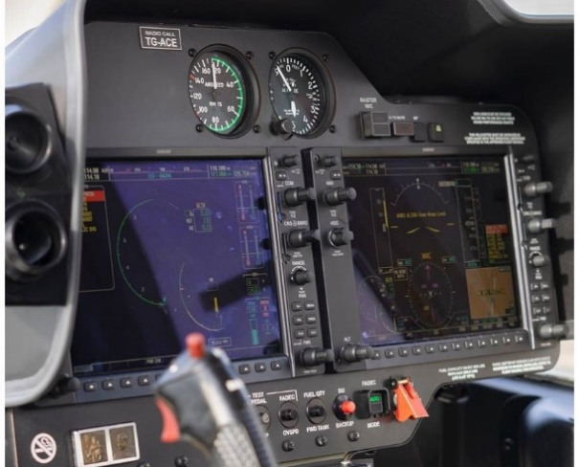
- Led Lighting (Interior/Exterior)
- Low Skid Gear
- Inlet Barrier Filter With Access Door
- Expanded Avionics Shelf
- Artex C406-NHM ELT With PGM Adaptor
- Headliner with AC Ducting
- Traffic Avoidance System GTS 800 TAS
- Cockpit Storage Kit
- Engine Fire Detector
- Door Opener Automatic for Baggage Door
- Door Opener Automatic for Cabin Door
- Locking Fuel Cap Kit
- Baggage Floor Protector

