Heading

2020 DIAMOND DA 62 - BASE PRICE: $1,135,000

POWER PLANT
- 2x Austro Engine AE 330 turbocharged common rail injected 2.0 Liter Diesel Engine with 180 HP and EECU single lever control system
- 2x MT Propeller MTV-6-R-C-F/CF 194-80
- 3-blade constant speed propeller
AVIONICS
- Integrated Garmin G1000 NXi Glass Panel Cockpit including:
- 2x Garmin GDU 105X 10-inch Flight Display (PFD & MFD)
- Garmin GEA 71B Airframe/Engine Interface Unit
- 2x Garmin GIA 64W COM/NAV/SBAS-GPS/GS/LOC
- Garmin GMA 1360 Digital Audio System
- Garmin GRS 79 Attitude Heading Reference System
- Garmin GDC 72 Digital Air Data Computer
- Garmin GMU 44 Magnetometer
- Garmin GFC 700 Automatic Flight Control System
- including Yaw Damper
- Garmin GTX 335 R REMOTE ADS-B Transponder
- Garmin FliteCharts Approach Plates (subscription required)
- ELT 406 MHz
- 2nd Digital Standby Attitude Module (MD-302 SAM)
- Garmin GWX 70 Weather Radar $36,780
- Garmin GCU 476 Keypad $22,140
- Garmin Synthetic Vision Technology $11,440
- Garmin GTX 345R ADS-B In/Out Transponder $5,050
- Garmin GDL 69A SXM SAT WX (3-month free trial subscription required) $11,000
INTERIOR EQUIPMENT
- Adjustable Backrest for Pilot/Copilot
- (with Adjustable Lumbar Support)
- USB Power Outlets - Pilot, Copilot, 2nd row pax
- Instrument Lighting
- Overhead Ambient Cabin, Reading and Map Lights
- Electrically Adjustable Rudder Pedals for Pilot/Copilot
- Pilot and Copilot Middle Armrest
- Dual Headset Plugs (6-Pin Headset Connector
- and Standard Jack Connector)
- Sunvisors for Pilot and Copilot
- Cargo Tray
EXTERIOR EQUIPMENT
- Hydraulic Retractable Landing Gear
- Heated Pitot Tube and Static Port
- High-gloss Multi Layer Paint (White)
- Variety of Exterior Striping Options
- Entry Steps and Entry Grips in aircraft color
- Registration Markings
- Electrically Operated Flap System
- Landing and Taxi Lights (HID-Xenon)
- Integrated Position and Strobe Lights with LED technology
SAFETY CONCEPT
- Composite Cabin and Safety Seats (up to 26g)
- “FAILSAFE” Airframe and Wing Design
- Multipath Lightning Protection System
- 3-point Safety Belts Automatic (all Seats)
- Garmin ESP (Electronic Stability Protection)
OTHER EQUIPMENT
- 86 US gal (326 lt) Long Range Fuel Tank
- Baggage Compartment
- Nose Baggage Compartment Acc Both Sides
- Pitot Cover
- Tow Bar, Tool Kit, Control Gust Lock
- First Aid Kit, Fire Extinguisher, Emergency Axe, Egress Hammer
- Air Conditioning/RACC II System (powered by an additional alternator) $36,780
- TKS De-Icing system $78,600
- Oxygen System $24,300
- Seating Configuration 3rd Row $29,400
- Diamond Metallic Paint $20,300

DELIVERY CHARGE $3,550

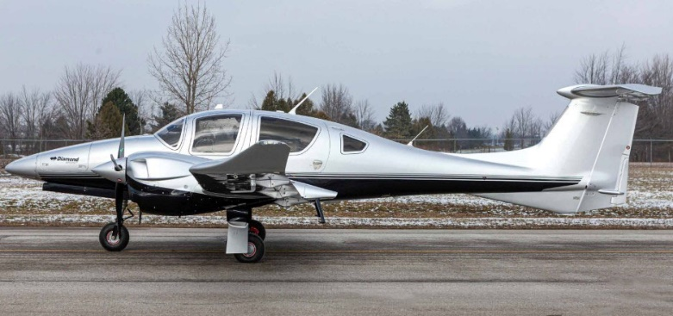

FACTORY WARRANTY & TRAINING
- Two-year factory warranty
- PistonPower airframe and engine maintenance program available at additional cost – call for details
- Factory-approved familiarization training

