Looking for a well-equipped APMG HondaJet but are not prepared to pay the price? We have the plane for you! This plane had damage due to a ground handling incident that was repaired by the Honda factory in Greensboro, NC. It has been substantially discounted for the incident.

The aircraft has the highest level of Honda factory maintenance programs on the airframe and engines. We are a stocking dealer that takes trades with a particular interest in single-engine turboprops. So, if 420 knots at 43,000 feet, Garmin’s latest avionics and Honda luxury is what you want, let’s talk.
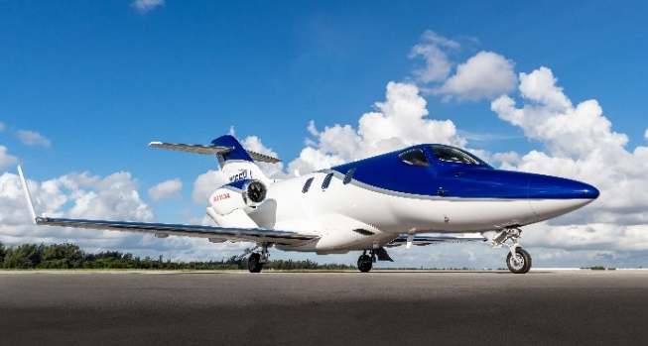

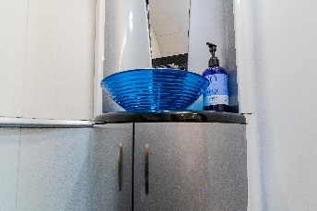
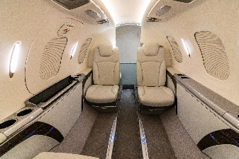
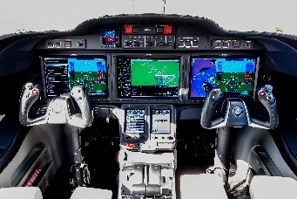

STATUS
- Total time: airframe: 360 hours with 378 cycles
- P3 maintenance contract programs until September 2022
- EMC2 until April 2024
EXTERIOR
- Brushed Ice Silver and Eucalyptus Trim Honda Signature Scheme in Blue Pearl
INTERIOR
- Moonlight Interior in Cool Gray with Dark Gray accent colors
- Externally serviced toilet
- Sink with running water
AVIONICS
- Garmin G3000 all-glass Avionics Suite
- Three 14.1” high-resolution displays showing flight instruments, navigation, communication, lighting controls, traffic, terrain, weather, aircraft systems status and alerting, checklists and more
- Dual touchscreen
- Display providing a primary point of access for the majority of all avionics data inputs and selections
- Integrated avionics which provides enhanced situational awareness, functionality, ease of operation and redundancy
- Dual PFDs showing flight instrument data and pilot-selectable information in a 40:60 ratio split screen
- Three types of weather information - Connext, XM, radar
- Radar altimeter
- Jeppesen ChartView
- Dual extended squitter transponders with ADS-B Out
- Telephone, text, and music

ACCESSORY EQUIPMENT
- Executive seat upgrade
- Life vests
- Crew seats leather upgrade
- Solid aft cabin door
- FIKI approved
- RSVM capable
- Speed brake
- Anti-skid brakes
- Logo lights
- Personal storage compartments
- Cabin power-forward seats
- Cabin floor trim upgrade
- Electric pleated shades
- LH/RH executive table
- Carbon fiber cabinet face upgrade
- RH side-facing seat
- LH storage cabinet
- Single-point refueling

MAINTENANCE PROGRAMS
- Complete highest level of maintenance
- P3 maintenance contract programs until September 2022
- EMC2 until April 2024

