This exceptional no damage history Matrix is close to new inside and out. Sale includes a Premier annual with zero since prop overhaul and engine is covered under PistonPower™ engine warranty until 2021. ADS-B and WAAS equipped and one-year Avidyne warranty! Always hangared, Michigan based most of its life, trades considered, and free Premier Matrix pilot course included with sale. Perfect step up from Cirrus, Cessna or Piper!

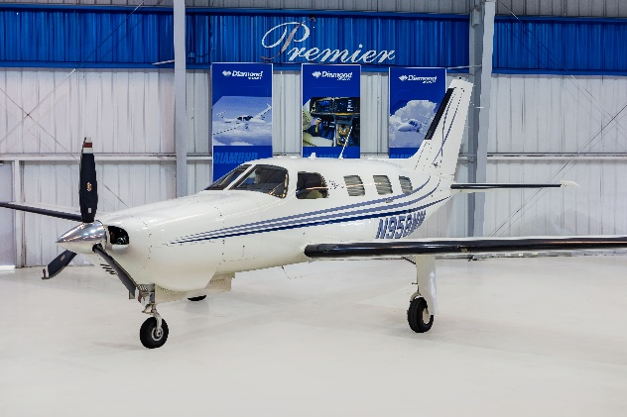
STATUS
- Total time, airframe: 1,399 hours
- Engine: 1,399 with extensive top overhaul in 2017
- Under PistonPower™ engine program until September 2021
- Propeller: zero since overhaul
- No damage history
- Useful load: 1,277.7
- Annual: February 2020 by Premier Aircraft Service
- Complete pre-buy inspection completed

EXTERIOR/INTERIOR – Like New!
- Matterhorn white with two-tone blue accents
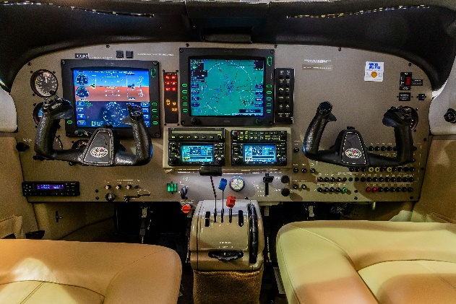
- Deluxe six seat club interior group
- Executive writing table
- Premium tan leather

AVIONICS
- Avidyne FlightMax Entegra integrated flight deck
  - Integra PFD
  - FlightMax EX5000 Multi-Function Display System with EMax Engine Monitoring System
- Dual Garmin GNS430W GPS/COMM/NAV
- Garmin GMA-340 Audio Panel/intercom
- Garmin GTX-335 ADS-B Transponder
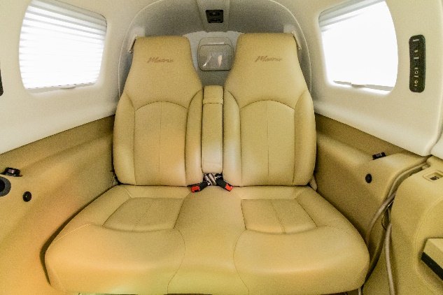
- Avidyne Twx-670 Tactical Weather Detection and Avoidance (StromScope)
- Avidyne dual antenna TAS-610 active traffic system
- MLB 700 data link receiver – NEXRAD weather

AUTOPILOT
- STEC55X Dual Axis Autopilot with electric trim

ADDITIONAL EQUIPMENT
- Full deice group with flight into known icing certification (FIKI)
- Speed brakes
- Piper factory air conditioning system
- Six place 50.1 cubic ft. Built-in oxygen system

