ADS-B out compliant, Avidyne glass panel, New Avidyne IFD 440 Navigators, air conditioned

STATUS
- Total time, airframe: Only 2,678 hours since new (subject to change)
- Engine: 504 hours since major overhaul – February 2016
- Prop: 504 hours since major overhaul – January 2016
- Minor hangar rash repair – 2008
- Annual: April 2019
- Useful load: 1,028 pounds

EXTERIOR/INTERIOR
- Green metallic with Slate Gray and silver metallic accents over white
- Grey deluxe leather interior – freshly reconditioned
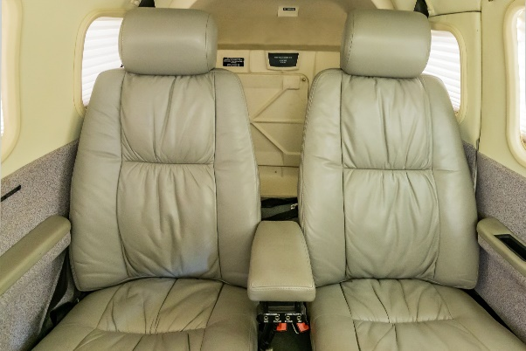
- Executive writing desk
- Refreshment console with portable cooler
- Pilot and copilot vertically adjusting seats
- Overhead passenger reading lamps

AVIONICS
- Avidyne Flightmax Entegra primary flight display
- Coupled to system 55X with altitude and rate pre-select
- H.S.I / FD, altitude, rate of climb, MAP, RPM, active navigation presentations
- Entegra multifunction flight situation display
- EMAX - engine monitoring, fuel management
- Dual Avidyne GPS/ILS/VOR/LOC/COM/WAAS Navigators
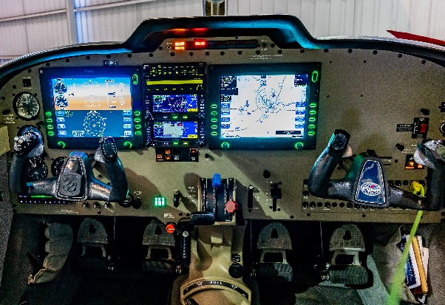
- Garmin GMA-340 audio switching panel with marker beacon
- Avidyne AXP340 ADS-B out transponder
- Active traffic system
- L3 WX500 Stormscope
- CMAX approach charts (subscription required)
- Avidyne XM data receiver
- Midcontinent electric standby attitude indicator
- Artex ME406 ELT
- Six place intercom system

AUTOPILOT
- S-TEC System 55X autopilot with flight director and GPSS

ADDITIONAL EQUIPMENT
- PiperAire air conditioning
- Pulse Lights
- 6-place oxygen system – 50 cu. Ft.
- External power receptacle

