Low Time, Platinum Interior, Reclining Seats,

Electric Rudder Pedals and ADS-B in and out

STATUS

- Total time, airframe: 770 Hours
- Engines: 770 Hours
- Propellers: 80 Hours SOFH
- Annual: January 2020 at Diamond Service Center
- No damage history

EXTERIOR/INTERIOR
- Exterior trim: Three-color Autumn Maple, Silver, Gold
- Interior: Platinum Trim Package including;
- Two-tone leather seats
- Chrome look trim
- Pilot and copilot reclining seats with lumbar support
- Electric adjustable rudder pedals
- Upgraded carpet
- Wood-grain inlays

AVIONICS
- GDU1040, 10-inch Primary Flight Display
- GDU1040, 10-inch Multi-Function Display
- Garmin Integrated VFR Terrain Awareness System
- GEA71 Airframe/Engine Interface Unit
- Dual Garmin GIA 63 COM/NAV/GPS
- GMA1347 Digital Audio System
- GTX-345R Transponder – ADS-B in & out
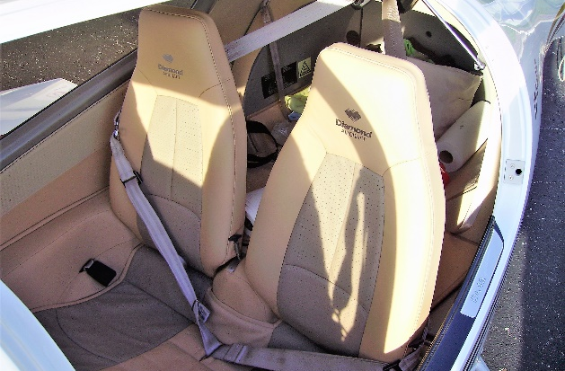
- VFR Terrain Awareness System
- GRS77 Solid-State Attitude Heading Reference System
- GDC74 Digital Air Data Computer
- GMU44 Magnetometer
- Standby instruments (compass, horizon, air speed indicator, altimeter)
- Composite cabin and safety seats (up to 26g)
- Lightning protection system
- Fire extinguisher
- FAILSAFE Airframe Design
- Three-point safety belts automatic (all seats)
- Hydraulic retractable landing gear
- High-intensity discharge landing and taxi lights
- Position and anti-collision lights
- 4-way baggage compartment system
- Nose baggage compartment accessible from both sides
- ELT ARTEX 406 MHz

AUTOPILOT
- Honeywell KAP140 Dual-Axis Autopilot with Altitude Hold and Preselect

ADDITIONAL EQUIPMENT
- Long Range Fuel Tanks– (79 U.S. gallons)
- Garmin GDL69A Satellite Data Link, Weather and XM Radio
- Integrated Avidyne TAS 610 Traffic Advisory System
