December 2020 delivery!
The DA40 NG is an all-round practical and versatile 4-seat airplane for the 21st century.
Personal flying, instruction, cross country transportation,
The DA40 NG offers a unique blend of practicality, performance,
Value and unmatched diesel engine operating economy.

2020 DIAMOND DA 40 NG - BASE PRICE: $473,690

POWER PLANT
- Austro Engine AE300 Turbocharged Common-Rail Injected 2.0 Liter Diesel Engine with 168HP and EECU Single Lever Control System
- MT Propeller MTV-6-R/190-69 3-Blade Constant Speed Propeller
AVIONICS
- Integrated Garmin G1000 NXi Glass Panel Cockpit including:
- 2x Garmin GDU 105x 10-inch Flight Display (PFD & MFD)
- Garmin GEA 71B Airframe/Engine Interface Unit
- 2x Garmin GIA 64W COM/NAV/SBAS-GPS/GS/LOC
- Garmin GMA 1360 Digital Audio System
- Garmin GRS 79 Attitude Heading Reference System
- Garmin GDC 72 Digital Air Data Computer
- Garmin GMU 44 Magnetometer
- Garmin GTX 335R Remote ADS-B Transponder
- Garmin FliteCharts Approach Plates (subscription required)
- ELT 406 MHz
- Standby Instruments (Compass, Attitude Indicator, Air Speed
- Indicator (kts), Altitude Indicator (ft))
- Garmin GFC 700 Automatic Flight Control System $32,550
- Garmin GTX 345R ADS-B In/Out Transponder $5,050
- Garmin Synthetic Vision Technology $11,440
INTERIOR EQUIPMENT
- Ergonomic Seats and Backrests
- Adjustable Pilot and Copilot Seats
- Sun Glare Shields and Canopy Lining
- 28 V Power Supply Socket
- Instrument Lighting
- Overhead Cabin Light
- Baggage Extension with Separate Compartment
EXTERIOR EQUIPMENT
- Heated Pitot Tube
- High-gloss Multi Layer Paint
- Standard Exterior Striping
- Electrically Operated Flap System
- Wheel Fairings on Main and Nose Landing Gear
- Landing and Taxi Lights with LED Technology
- Position and Strobe Lights with LED Technology

SAFETY CONCEPT
- Composite Cabin and Safety Seats (up to 26g)
- “FAILSAFE” Airframe and Wing Design
- Lightning Protection System
- 3-point Safety Belts Automatic (All Seats)
OTHER EQUIPMENT
- 39 US gal (147 liter) Long Range Fuel Tank
- Noise Reduction Muffler
- Pitot Cover
- Control Gust Lock
- Tow Bar And Tool Kit
- First Aid Kit, Fire Extinguisher, Emergency Axe
- Air Conditioning/RACC System (powered by an additional alternator) $32,110
- Electrically Operated Adjustable Rudder Pedals for Pilot and Copilot $7,260

DELIVERY CHARGE $2,550

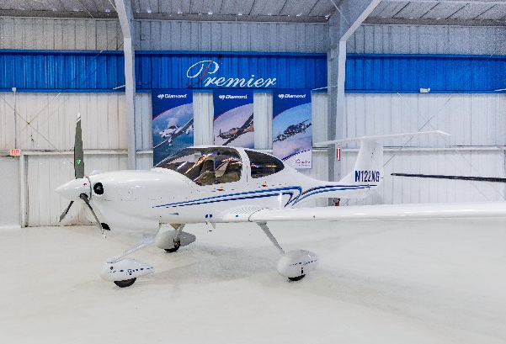
File Photo
FACTORY WARRANTY & TRAINING
- Two-year factory warranty
- PistonPower airframe and engine maintenance program available at additional cost – call for details
- Factory-approved familiarization training

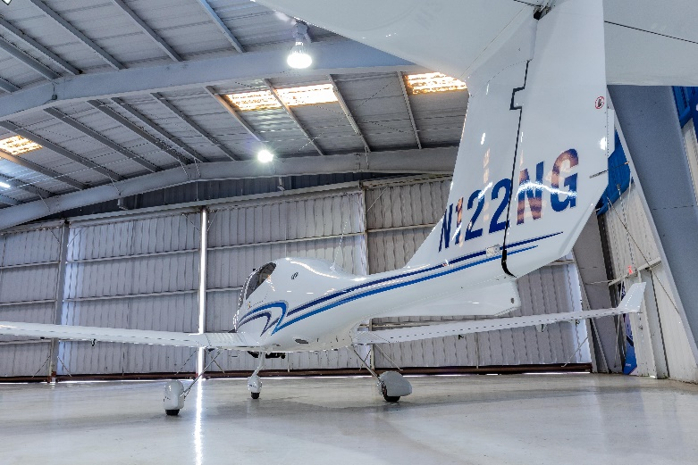

File Photo

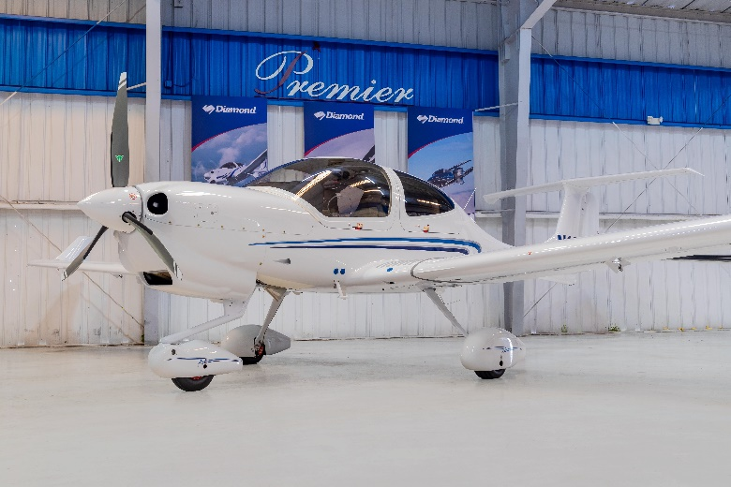

File Photo

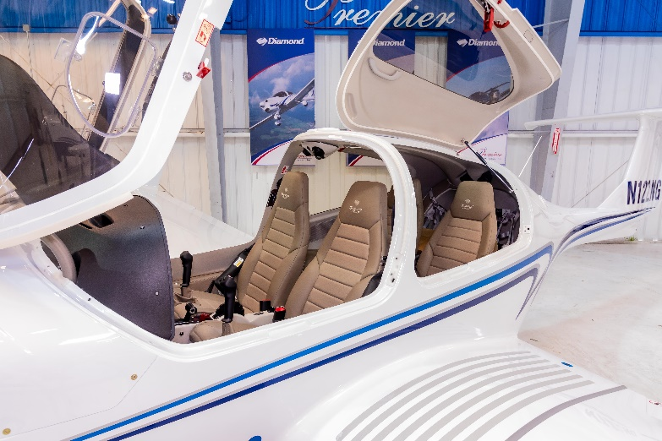
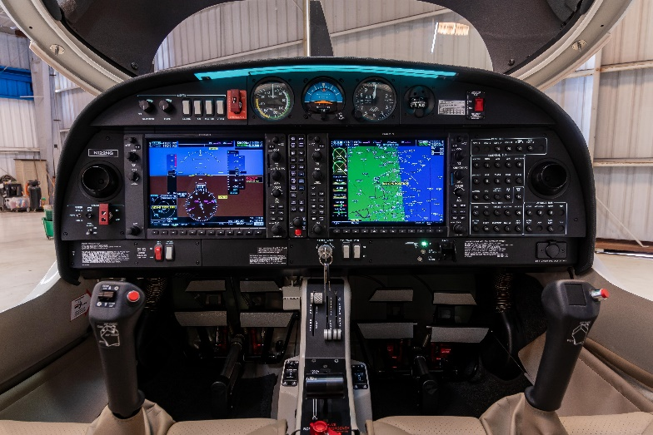
File Photo
File Photo
File Photo
File Photo

