2016 PIPER M350
n350HN– SN 4636681
Price: INQUIRE
Trades welcome

ABSOLUTELY LIKE NEW IN EVERY WAY—GARMIN ENHANCED AFCS,
NEW STYLE MOTOR MOUNT, LED LIGHTS, GARMIN 33ES ADS B OUT, ASPEN GLASS BACKUP INSTRUMENTS, FOLDING SEATS IN LATEST PIPER CONFIGURATION
ELEGANT THREE TONE PAINT AND DUNE LEATHER SEATING

STATUS
- AIRFRAME TOTAL TIME: 340 HOURS
- ENGINE TOTAL TIME: 340 HOURS—UNDER WARRANTY UNTIL 2021
- PROPELLER TOTAL TIME: 340 HOURS
- ANNUAL: JANUARY 2019
- NO DAMAGE HISTORY
EXTERIOR

ELEGANT PAINT COLORS – matterhorn WHITE OVER charcoal with bahama blue accents

INTERIOR-PREMIUM UPGRADED—LIKE NEW!
- DUNE NEW ZEALAND BULL HIDE LEATHER INTERIOR WITH MATCHING CARPET
- DELUXE SIX SEAT CLUB INTERIOR GROUP
- BUILT-IN EXECUTIVE WRITING TABLE
- FOLD DOWN SEATS FOR EASIER ACCESS TO CREW SEATS

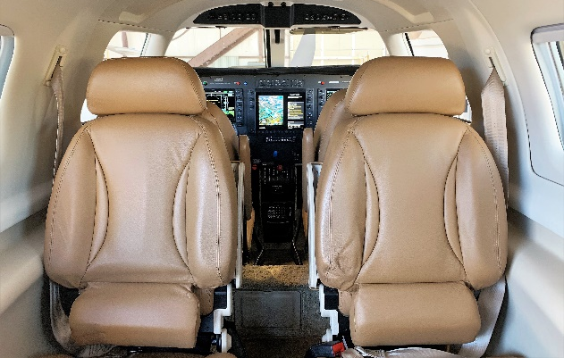
Avionics
GARMIN G1000 AVIONICS SUITE:
- SYNTHETIC VISION
- 10” PFD PILOT AND COPILOT WITH SINGLE 12.2” MFD
- GARMIN GMA-350 DIGITAL AUDIO PANEL
- DUAL GARMIN GIA-63W NAV/COM/GPS WAAS ENABLED
- DUAL GARMIN GDC 74A AIR DATA COMPUTERS
- GARMIN GTX 33ES TRANSPONDER WITH ADS B OUT
- GARMIN GWX-68 COLOR WEATHER RADAR
- GARMIN GCU-476 KEYPAD
- GARMIN GDL 69A SATELLITE RADIO/WEATHER RECEIVER WITH MUSIC
- JEPPESEN CHARTVIEW
- GARMIN FLITECHARTS AND SAFE TAXI
- ASPEN EFD 1000 GLAS STAND-BY FLIGHT INSTRUMENT
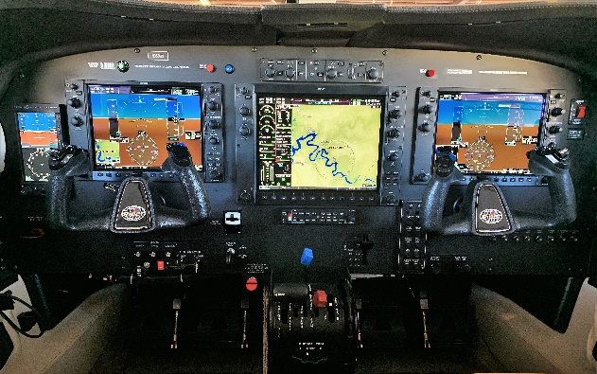
- GARMIN TAWS-B
- GARMIN GTS 825 TRAFFIC SYSTEM

AUTOPILOT
- GFC 700 AUTOPILOT WITH GMC-710 AP CONTROLLER

ADDITIONAL EQUIPMENT
- FLIGHT INTO KNOWN ICING (FIKI)
- SPEED BRAKES
- YAW DAMPER SYSTEM
- PIPERAIRE AIR CONDITIONING
- LED PULSE LIGHT ANTI-COLLISION SYSTEM

REMAINING FACTORY ENGINE WARRANTY UNTIL JULY 2021

