This is a highly desirable, well-equipped APMG HondaJet ready for immediate delivery.
Aircraft began its life as a corporate plane for Honda itself.
We are selling for the first operator in Miami, Florida.
The aircraft has the highest level of Honda factory maintenance programs on the airframe and engines. We are a stocking dealer that takes trades with a particular interest in single-engine turboprops. So, if 420 knots at 43,000 feet, Garmin’s latest avionics, Honda luxury and big savings over a new plane is what you want, let’s talk.
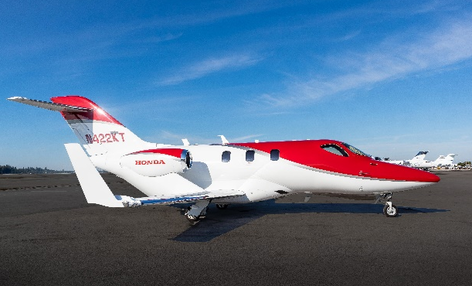

- STATUS
- Total time: airframe: 520 hours
- P3 maintenance contract programs
- EMC2
- EXTERIOR
- Signature Red Pearl Paint Scheme
- INTERIOR
- Tan interior with dark tan accent colors
- Externally serviced toilet
- AVIONICS
- Garmin G3000 all-glass Avionics Suite
- Three 14.1” high-resolution displays showing flight instruments, navigation, communication, lighting controls, traffic, terrain, weather, aircraft systems status and alerting, checklists and more
- Dual touchscreen
- Display providing a primary point of access for the majority of all avionics data inputs and selections
- Integrated avionics which provide enhanced situational awareness, functionality, ease of operation and redundancy
- Dual PFDs showing flight instrument data and pilot-selectable information in a 40:60 ratio split screen
- Two types of weather information – Connext and radar
- Radar altimeter
- Jeppesen ChartView
- Dual extended squitter transponders with ADS-B Out
- Telephone, text, and music

ACCESSORY EQUIPMENT
- Executive Package
- LH Storage Cabinet
- RH Forward Side-Facing Seat Cabinet Carbon Finish Executive Cabin Seats
- Lighted Floor Trim
- Personal Storage Compartments
- LH Stowable Executive Table
- Crew Leather Seat Upgrade
- Cabin Power Outlets #2
- Solid Aft Cabin Door
- Enhanced Cabin Management System
- Externally Serviceable Toilet Life Vests
- Med Aire First Aid Kit
- Electronically dimmable windows (EDW)
MAINTENANCE PROGRAMS
- Complete highest level of maintenance
- P3 maintenance contract programs until August 2022
- EMC2 until December 2024

