SPECTACULAR 300-KNOT ROCKETSHIP! IMAGINE CLIMBING TO 28,000 FT AT 4,000 FPM
AND FLYING 1,000 NM IN A PRESSURIZED, 7,000 FOOT CABIN! FIGHTER PLANE PERFORMANCE FOR THE PRICE OF A CIRRUS!A COMPLETE TRAINING COURSE FROM A NATIONALLY KNOWN EVOLUTION INSTRUCTOR INCLUDED IN SALE!

STATUS
- TOTAL TIME, AIRFRAME, ENGINE AND PROPELLER: 720 HOURS
- ENGINE: PT6A-135 750 SHP
- PROPELLER: HARTZELL 4-BLADE, CONSTANT SPEED, REVERSIBLE
- PROFESSIONALLY BUILT BY KEVIN JACKSON
- JUNE 2019 ANNUAL CONDITION INSPECTION BY CAM FACTORY EVOLUTION SERVICE CENTER
- NO DAMAGE HISTORY
- USEFUL LOAD: 1926 LBS; 800 LB FULL FUEL PAYLOAD

EXTERIOR/INTERIOR
- CREAMY WHITE OVER CHOCOLATE BROWN WITH GOLD AND SILVER ACCENT STRIPES
- TWO TONE TAN AND BROWN 4-PLACE LEATHER INTERIOR
- ADJUSTABLE RUDDER PEDALS MOVE FORE AND AFT

AVIONICS
- EVOLUTION EFC900X AVIONICS SYSTEM
- GARMIN 900X INTEGRATED GLASS PANEL
- DUAL GARMIN GIA63W WAAS COM/NAV/GPS
- GARMIN GMA 1347 DIGITAL AUDIO CONTROL PANEL/
- GARMIN GTX33 MODE S TRANSPONDER
- GARMIN GTS 800 ACTIVE TRAFFIC SYSTEM
- GARMIN TERRAIN AWARENESS SYSTEM
- GARMIN SYNTHETIC VISION SYSTEM
- GARMIN GRS 77 SOLID-STATE ATTITUDE HEADING REFERENCE SYSTEM
- GARMIN GDC74 AIR DATA COMPUTER
- GARMIN GMU 74 MAGNETOMETER
- ARTEX 406 MHZ ELT
- GARMIN GDL69A SATELLITE DATA SYSTEM
- NEXRAD WEATHER
- TEXT AND GRAPHIC WEATHER
- LIGHTNING STRIKE DATA
- XM MUSIC AUDIO ENTERTAINMENT
- BOSE (LEMO) POWERED HEADSET JACKS, ALL FOUR SEATS
- GARMIN GCU 476
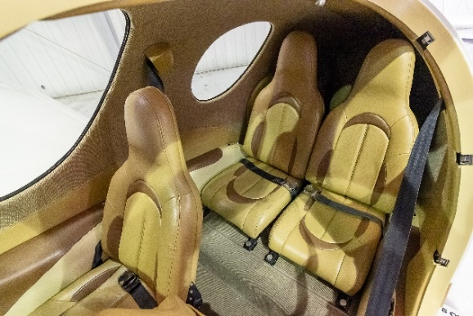
- RADIANT AEROSPACE (MORITZ) TOUCHSCREEN MODE CONTROLLER
- CONTROLS PRESSURIZATION, HEAT AND AIR CONDITIONING AND ELECTRONIC CIRCUIT BREAKERS
- L3 TRILOGY ELECTRONIC STANDBY ATTITUDE INSTRUMENT (ESI)

AUTOPILOT

GARMIN GFC700 DIGITAL FLIGHT CONTROL SYSTEM

YAW DAMPER

ADDITIONAL EQUIPMENT
- DUAL SIDE STICK CONTROLLERS
- INCLUDES PUSH-TO-TALK, AUTOPILOT DISCONNECT, TRANSPONDER IDENT, ELEVATOR TRIM AND CWS SWITCHES
- EVOLUTION SOFT FIELD LANDING GEAR
- 18 X 6.5 – 8 12-PLY TUBELESS TIRES
- FUEL CAPACITY 168 U.S. GALLONS
- OXYGEN SYSTEM
- LED WING STROBES AND POSITION LIGHTS
- AIR CONDITIONING
- LED LANDING AND TAXI LIGHTS
- CO GUARDIAN ELECTRONIC CARBON MONOXIDE DETECTOR
- SOFT FIELD LANDING KIT
- LARGE BAGGAGE COMPARTMENT
