Air! WAAS! TAS! TAWS-B! ADS-B Out!
2008 Cessna 400 SL with G1000, GFC700
N409HA Ser#411039

866 Total Time Since New

Avionics:

Garmin G1000 Avionics
GDU 1040 Primary Flight Display (PFD) - 10.4" high resolution XGA
GDU 1044 Multi-Function Display (MFD) - 10.4" high resolution XGA
GCU476 ReadyPad Controller
GEA71 Engine/Airframe Interface
GRS77 Attitude Heading Reference System (AHRS)
GDC74A Solid State Air Data Computer (ADC)
GMU44 Magnetometer
GDL69A Datalink - XM Weather & Radio
Terrain Awareness System (E-Prox+TM)
Dual Nav/Comm (16 Watt)
GTX-335R with WAAS Transponder with ADS-B Out
GMA1347 Digital Audio Panel with Marker Beacon / Intercom
Avidyne TAS600 Traffic Advisory System
Backup Airspeed, Altimeter and Attitude Indicator
Garmin GFC700 Integrated Two-axis Autopilot
Flight Director
Go-Around Button
Control Wheel Steering
Garmin SafeTaxi & FliteCharts

Performance & Design:
235 Knots Maximum Speed at FL250
200 Knots on 16.5 Gallons Per Hour at 17,000’
1200 Nautical Mile Maximum Range
59 Knot Stall Speed
Utility Category – Stronger than the Competitors
Best Handling Aircraft in Class
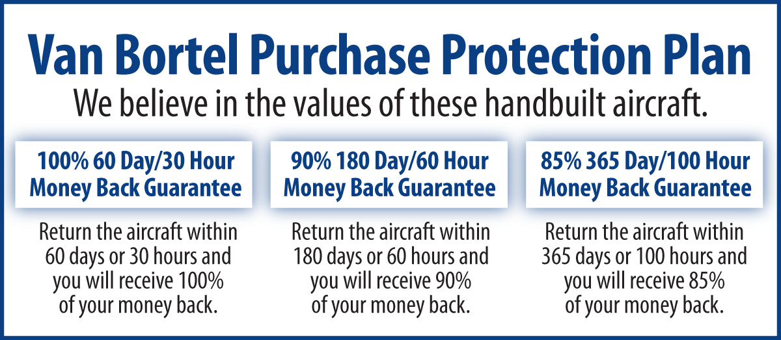
Easy to Fly!
Additional Equipment:
Automatic Climate Control System with Air Conditioning
Precise Flight Speed Brakes
Precise Flight Built in 4-Place Oxygen
Integrated Checklist
Avionics Data Logging
WAAS Equipped
Garmin 0534.21 System Software
TAWS-B
Oregon Aero Hi-G Seats
Inflatable Door Seals
Independent, Dual Electrical Systems
Propeller Heat
ADS-B Out

Engine:
Continental TSIO-550-C(11)
Platinum Engine Option w/Tuned Injectors
Tempest Fine Wire Spark Plugs
Oil Cooler Winterization Kit

Maintenance:
All Life Limited Parts Complied With
All Mandatory Service Bulletins Complied With
No one maintains more Cessna 400’s than Van Bortel!

Exterior:
White and Glacier Blue with Gold Fire Mist Stripes

Interior:
Tan Leather

We fly the aircraft to your ramp for inspection by you and your mechanic at no cost or obligation to you.

All Specifications Subject To Verification Upon Inspection

Trades Welcome • No Damage History • Always Hangared • No Corrosion

