ONE OF A KIND 1976 PIPER AZTEC TURBO-F • UNBELIEVABLY EQUIPPED • LOW TIME AIRFRAME, ENGINES AND 3 BLADED PROPS • UPDATED LATEST GENERATION AVIONICS • UPDATED PAINT AND INTERIOR • NONE LIKE THIS ONE ON THE MARKET OR MAYBE ON THE PLANET!

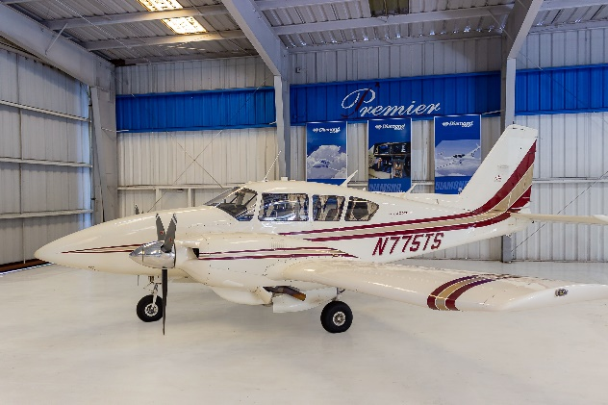
STATUS
- AIRFRAME: 2,180 HOURS
- ENGINES: 370 HOURS SMOH
- PROPELLERS: 370 HOURS SINCE NEW
- ANNUAL: SEPTEMBER 2018
- DAMAGE HISTORY; CALL SALESMAN

EXTERIOR/INTERIOR
- EXTERIOR TRIM: OUTSTANDING BEIGE WITH MAROON AND GOLD STRIPES (SKY HARBOUR LATE 1990’S)
- INTERIOR: BEAUTIFUL BEIGE CUSTOM LEATHER INTERIOR (ORMOND BEACH AIRCRAFT)
- BURLWOOD FINISHED PANEL
AVIONICS
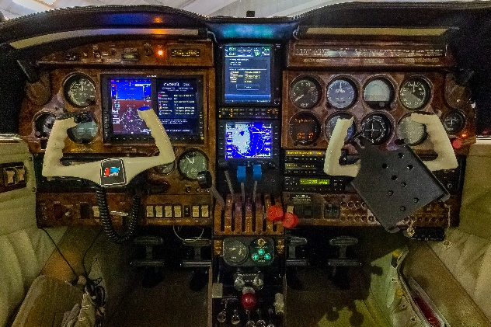
- GARMIN GTN 750
- AVIDYNE FLIGHT MAX EX 600 MFD
- GDU 620 PFD
- GARMIN G500 MULTIFUNCTION DISPLAY
- APOLLO SL 15 AUDIO PANEL
- APOLLO SL 30 NAV/COM
- GARMIN GDL 88 ADSB OUT
- GARMIN 330 TRANSPONDER
- BENDIX RADAR
- ANGLE OF ATTACK INDICATOR
AUTOPILOT
- PIPER AUTO CONTROL III WITH ALT HOLD (GPSS)

ADDITIONAL EQUIPMENT
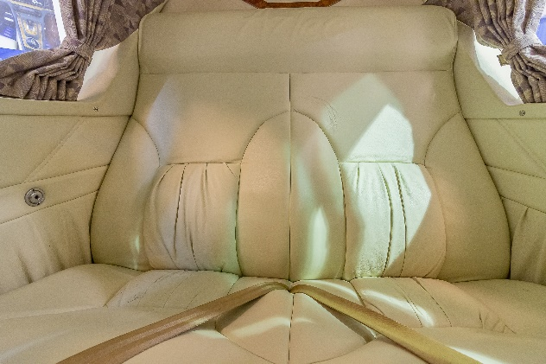
- SIX PLACE OXYGEN SYSTEM
- ENGINE PRE OILERS
- LO PRESTI BOOM BEAM LIGHTS WITH PULSLITES
- GRAT LAKES WINDSHIELD; ALL WINDOWS ¼ INCH THICK
- DUAL HYDRAULIC PUMPS
- VORTEX GENERATORS
- LARGE DORSAL FIN
- LONG RANGE FUEL
- FLAP GAP SEALS
- GAMI FUEL INJECTORS
- NULITE INSTRUMENT PANEL LIGHTING
- JPI EDM 760 ENGINE MONITOR
- AIR WOLF AIR/OIL SEPARATORS

