Garmin GFC 700 Autopilot, SVT, XM, Air Conditioning, Ovation 3 Upgrade

STATUS
- Total time, airframe: 775 hours
- Engine: 775 hours
- Propeller: 775 hours
- Annual: June 2020 – Mooney Service Center

EXTERIOR/INTERIOR
- Exterior trim: Matterhorn White Crown with Flight / Bright Red Base
- Interior: tan leather
- 3 Passenger Rear Bench Seat

AVIONICS
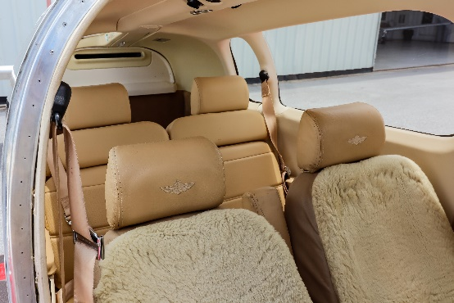
- Garmin GDU 1040, 10” Primary Flight Display, three-axis flight dynamics, air speed, altitude, VS, HSI with perspective md
- Garmin GDU 1040, 10” Multi-Function Display
- Garmin GDC 74A Integrated Digital Air Data Computer, constant display of TAS, CAS, wind direction, VSI and TAT
- Dual Garmin GIA63, integrated radio modules with IFR approved GPS, VHF navigation with ILS and VHF communication with 16-watt 8.33-kHz transceivers
- GMA 1347 Digital Audio Controller with Integrated Marker Beacon /Intercom
- GTX 345R Transponder – ADS-B In & Out
- Garmin GDL 69A Satellite Data Link - weather radar, satellite text, graphic weather datalink and audio infotainment

AVIONICS OPTIONS
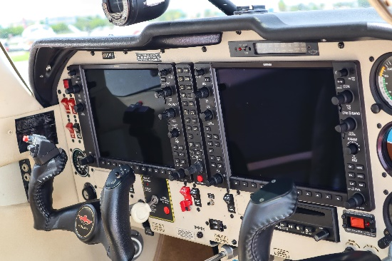
- Garmin GFC 700 Autopilot (altitude hold and trim, HDG preselect, electric trim, VS & FLC command, VOR/LOC/GS/REV/GPS coupling

ADDITIONAL EQUIPMENT
- Goodrich WX 500 Stormscope (overlays on Garmin)
- Attitude Indicator Stand-by Electrical
- Installation of hot-wire plugs for Bose (pilot and copilot only)
- CD player
- Avidyne TAS 600 Active Traffic
- Garmin SVT Synthetic Vision
AIRFRAME OPTIONS
- Precise Flight Speed Brakes
- Platinum engine
- Oxygen system (77.1 cubic foot tank)
- Air conditioning (25,000 BTU high capacity)
- Fuel tanks: 102 gallons useable
- Ovation 3 upgrade engine and prop

