Austro Powered, FIKI, One operator, maintained by Diamond Service Center

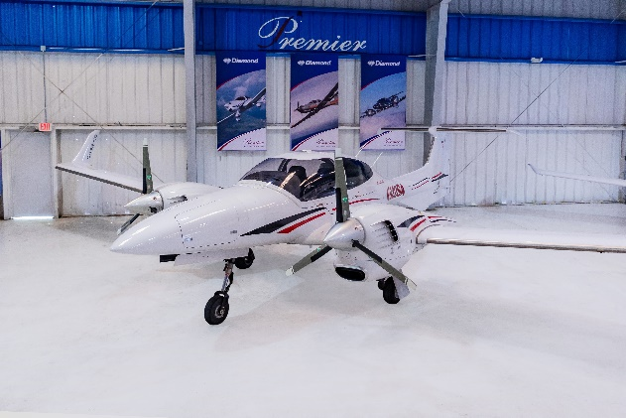
STATUS
- Total time, airframe: 3,960 hours (times are subject to change)
- Engines: 941 hours. Austro engines installed
in November 2016(1,800 HR TBO)
- Propellers: 941 SPOH in November 2013
- Useful load: 1,002 lbs.
- Annual: July 2020 by Diamond Service Center

EXTERIOR/INTERIOR
- Exterior trim: White with Blue, Silver and Burgundy accents
- Interior: Grey leather interior
- Pilot and copilot seats with black sheep skin seat covers

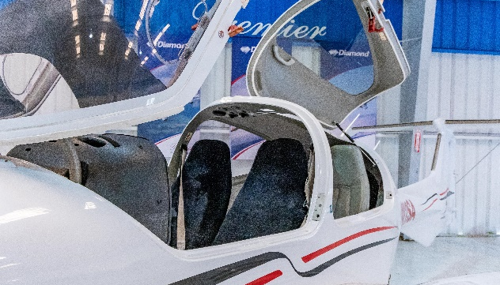
AVIONICS
- Garmin G1000 - GDU1040, 10-inch primary flight display and
multi-function display
- G-1000 with synthetic vision
- Remote avionics mounting rack with line replaceable units
- GEA71 airframe/engine interface unit
- Dual Garmin GIA 63 COM/NAV/GPS
- GMA1347 digital audio system
- GTX 345R – ADS-B in and out
- GRS77 solid-state attitude heading reference system
- GDC74 digital air data computer
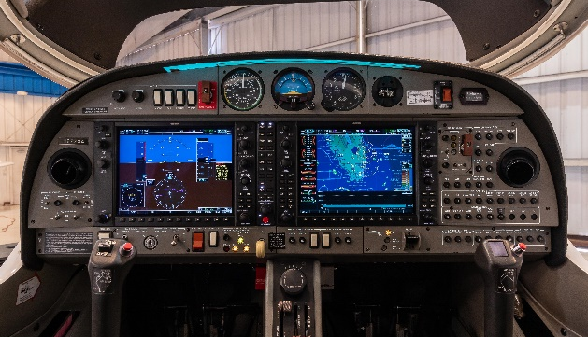
- GMU44 magnetometer
- GDL69A XM satellite weather and radio (subscription required)
- ELT ARTEX 406 MHz
- FliteCharts and SafeTaxi

AUTOPILOT
- GFC 700 - altitude hold/ preselect and yaw damper
- Standby instruments (compass, horizon, air speed indicator, altimeter)

ADDITIONAL EQUIPMENT
- Austro 300 Diesel Engines
- Auxiliary fuel tanks

