Rare, One Owner • Professionally Flown • Seven Seats • GFC700 WAAS • Radar • ADS-B Compliant • Air Conditioned • TKS Deicing • Oxygen
STATUS
- TOTAL TIME: 375 HOURS SINCE NEW
- ANNUAL INSPECTION: SEPTEMBER 2018
POWERPLANT AND PROPELLER
- 2X AUSTRO AE330 TURBOCHARGED 2.0 LITER 180HP DIESEL ENGINES
- ELECTRONIC ENGINE CONTROL UNIT, SINGLE LEVER CONTROL SYSTEM
- 2X MT THREE-BLADE CONSTANT SPEED PROPELLER
EXTERIOR TRIM AND EQUIPMENT
- TWO-TONE METALLIC SILVER WITH BLACK ACCENTS
- METALLIC PAINT OPTION
- 86-GALLON LONG-RANGE FUEL TANK
- TKS DEICING SYSTEM
- HEATED PITOT AND STALL WARNING
- HID-XENON LANDING AND TAXI LIGHTS
- LED INTEGRATED POSITION AND STROBE LIGHTS
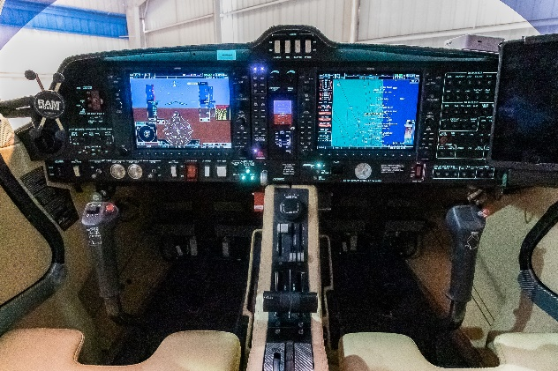
- HAND TOW BAR
INTERIOR TRIM AND EQUIPMENT
- ONYX PREMIUM LEATHER AND SEVEN-PLACE INTERIOR
- ELECTRICALLY ADJUSTABLE RUDDER PEDALS
- POWER OUTLET
- ADJUSTABLE PILOT AND COPILOT SEATS (WITH ADJUSTABLE LUMBAR SUPPORT)
- OVERHEAD AMBIENT CABIN LIGHTS, READING LIGHTS, AND MAP LIGHTS
- THIRD ROW SEATING CONFIGURATION (SEVEN PLACE)
- AIR CONDITIONING / RACC II SYSTEM
- SEVEN-PLACE OXYGEN SYSTEM
- TOOL KIT
- FIRST AID KIT, FIRE EXTINGUISHER, EMERGENCY AXE EGRESS HAMMER
AVIONICS
- GDU 1044, 10” PRIMARY FLIGHT DISPLAY
- GDU 1044, 10” MULTI-FUNCTION DISPLAY
- GEA 71 AIRFRAME / ENGINE INTERFACE UNIT
- DUAL GIA63W INTEGRATED COMM / NAV / WAAS IFR APPROVED GPS, VHF NAVIGATION WITH ILS
- GTX 33ES INTEGRATED MODE S TRANSPONDER ADS-B OUT
- GRS 77 ATTITUDE AND HEADING REFERENCE SYSTEM
- GARMIN GFC700 INTEGRATED AUTOPILOT WITH FLIGHT DIRECTOR, YAW DAMPER AND ELECTRONIC STABILITY PROTECTION (ESP)
- GDC 74A INTEGRATED DIGITAL AIR DATA COMPUTER
- GMA 1347 DIGITAL AUDIO CONTROLLER / INTERCOM / MARKER BEACON
- GMU 44 MAGNETOMETER
- AVIDYNE TAS 605 ACTIVE TRAFFIC ADVISORY SYSTEM
- GARMIN GWX 70 SOLID-STATE DIGITAL WEATHER RADAR
- GARMIN SYNTHETIC VISION TECHNOLOGY (SVT)
- GARMIN CHART VIEW APPROACH PLATES
- MID-CONTINENT MD302 ALL-IN-ONE ELECTRONIC STAND-BY INSTRUMENT WITH INDEPENDENT INTERNAL BATTERY BACK-UP

