Gorgeous custom paint – still under factory warranty – as new without the new price!

STATUS
- Total time, airframe: 250 hours (subject to change)
- Engine: 250 hours
- Propeller: 250 hours
- Annual: October 2019, 200-hour inspection completed
- No damage history

EXTERIOR/INTERIOR
- Exterior trim: metallic red with silver and black accents
- Interior: Black carbon leather and fabric

AVIONICS
- Integrated Garmin G1000 NXi glass panel cockpit, including:
- Dual Garmin GIA 64W with integrated radio modules with WAAS-enabled IFR-approved GPS; VHF navigation with ILS; and VHF communication with 16-watt transceivers
- Garmin GDU1040, 10-inch Multi-Function Display (MFD), Moving Map, Terrain, Traffic, Obstructions, EFIS, Flight Planning, Airport Data, GPS Satellite Data, Multi-Function Menus
- Garmin GDU1040, 10-inch Primary Flight Display (PFD), wide horizon, three-axis flight dynamics, air speed, altitude, vertical speed, horizontal situation indicator (hsi) with 350-degree and arc modes
- Garmin seven place intercom system
- Garmin FliteCharts (subscription required)
- Garmin GEA 71 Airframe/Engine Interface Unit
- GMA 1347 digital Audio Controller with Digital ATC Playback
- Garmin ESP (Electronic Stability and Protection)
- Garmin FliteCharts Approach Plates
- Garmin GCU 476 Keypad
- Garmin GDC 72 Digital Air Data Computer
- Garmin GDL69A SAT WX (subscription required)
- Garmin GMU 44 Magnetometer
- Garmin GRS 79 Attitude Heading Reference System Garmin GTX 335R Mode S Transponder (ADS-B Out)
- Garmin GWX 70 Weather Radar
- Garmin Synthetic Vision Technology (SVT)
- Avidyne TAS 605 Traffic Advisory System

AUTOPILOT
- Garmin GFC 700 Automatic Flight Control System (AFCS), including
two-axis digital autopilot with flight director and yaw damper

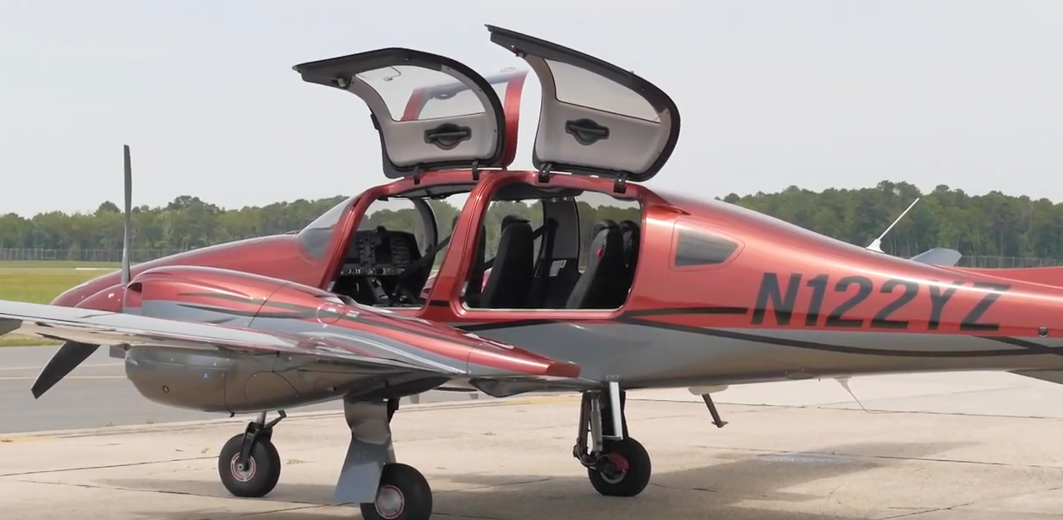

ADDITIONAL EQUIPMENT
- 2nd digital standby attitude module
- Three-point safety belts automatic (all seats)
- 86 US gallons long range fuel tank
- Adjustable backrest (with adjustable lumbar support)
- Air conditioning/RACC II system
- Avidyne TAS 605 Traffic Advisory System
- Black-out handles and steps
- Built-in tablet mount provisions
- Dual headset plugs (six-pin headset connector and standard jack connector)
- Electrically operated flap system
- Electronically operated adjustable rudder pedals
- ELT 406 MHz
- First aid kit, fire extinguisher
- Heated pitot tube and static port
- High gloss multi-layer paint
- Hydraulic retractable landing gear
- Instrument lighting
- Landing light and taxi lights (HID-Xenon)
- LED integrated position and strobe lights
- Multipath lightning protection system
- Oxygen system
- Pilot and copilot middle armrest
- Pitot cover, control lock, tow bar, tool kit
- Professional sunshades for Pax row 2nd and row 3rd
- Seating configuration for 3rd row
- Sun visors for pilot and copilot
- TKS FIKI deicing system
- USB power outlets, pilot, copilot, passenger 2nd row

