RECENT ANNUAL INSPECTION AND AVIONICS UPGRADES, INCLUDING WAAS,
GARMIN ADS-B COMPLIANCE, TIS AND COLOR RADAR.

STATUS
- Total time, airframe: 4,330 hours
- Left engine: 198 hours since Gold Medallion Factory Reman overhaul installed 2/16/2016 in Venezuela
- Right engine: 1,026 hours since Penn Yan Aero overhaul on 5/17/2007 installed by Airmods & Repair, Inc (NJ, USA) on 6/1/2007
- Left propeller: 128 hours since overhaul by Aheliven (Venezuela) on 11/14/2016
- Right propeller: 258 since overhaul by Aheliven (Venezuela) on 12/2/2014
- Annual: February 2020 by Premier Aircraft Sales

EXTERIOR/INTERIOR
- Exterior trim: White over Blue with metallic accents
- Interior: Tan leather seats with crew sheepskin seat covers and wool carpet

AVIONICS
- King KMA 24 Audio Panel
- Garmin GNS 530W
- King KY197 COM
- GTX330ES with ADS-B, TIS, displayed on G530W
- Color radar with vertical profile
- KNS80 RNAV
- KCS 55A Slaved HSI
- JPI EDM 760 graphic engine analyzer
- King KR 87 ADF
- Flight Com 403
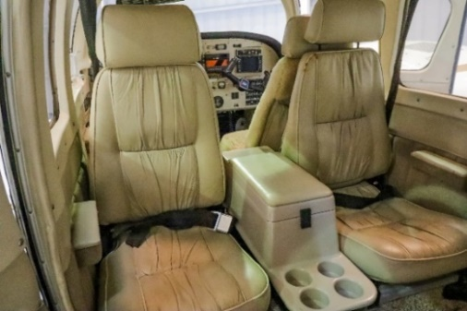
- Six place Stero intercom with pilot isolation
- Clearance recorder
- Music interface

AUTOPILOT
- King KFC-200 Autopilot and Flight Director with altitude hold

ADDITIONAL EQUIPMENT
- Knot 2U speed kit
- Long range tanks
- Built-in 6-place oxygen
- Stainless steel fasteners
- Cleveland wheels and brakes
- Wingtips with landing/recog lights
- Hartzell three-blade full-feathering propellers
OTHER EQUIPMENT & AIRFRAME UPGRADE
- Norton Radome
- Life Raft
- Six- life jackets

