Immediate Availability. Full Factory Warranty and Special Demonstrator Pricing. Most Capable and Fuel-Efficient and Economical Twin Ever Manufactured. Seating For 7. Equipped with the Garmin G1000 NXi, TKS, Air Conditioning and Much More.

STATUS
- Total Time: Airframe, Engines and Propellers: 275 Hours
- October annual at Diamond Factory in London, Ontario
- Full Diamond, Austro and Garmin warranties
POWER PLANT
- 2x Austro Engine AE 330 turbocharged common-rail injected 2.0 liter diesel engine with 180 HP and EECU single-lever control
- 2x MT 3-blade constant speed propellers
EXTERIOR
- Charcoal over silver with light and dark blue accents stripes in high-gloss multi-layer paint
- HID xenon landing and taxi lights
- LED position and strobe lights
INTERIOR
- Elegant black leather with seating for 7
- Adjustable backrest with adjustable lumbar support
- USB power outlets - pilot, copilot, passenger 2nd row
- Overhead ambient cabin, reading and map lights
- Electrically adjustable rudder pedals for pilot/copilot
- Pilot and copilot middle armrest with built in Flight Management System keypad

AVIONICS
- Integrated Garmin G1000 NXi Glass Panel Cockpit, including:
  - 2x Garmin GDU 105X 10-inch Flight Displays (PFD and MFD)
  - Garmin GEA 71 Airframe/Engine Interface Unit
  - 2x Garmin GIA 63 WAAS COM/NAV/GPS/GS/LOC
  - Garmin GMA 1347 Digital Audio System
  - Garmin GRS 79 Attitude Heading Reference System
  - Garmin GDC 72 Digital Air Data Computer
  - Garmin GMU 44 Magnetometer
  - Garmin GFC 700 Autopilot with Yaw Damper
  - Garmin GTX 335 R Mode S Transponder (ADS-B Out)
  - Garmin FliteCharts Approach Plates (subscription req.)
  - ELT 406 MHz
  - Digital Standby Attitude Module (MD-302 SAM)

AVIONICS – INSTALLED OPTIONS
- Honeywell KN 63 remote DME
- Becker 3500 remote ADF
- Avidyne TAS 605 Traffic Advisory System
- Garmin GWX 70 Weather Radar
- Garmin GSR 56 Iridium Satellite Datalink (subscription required)
- Garmin GCU 476 Keypad
- Garmin Synthetic Vision Technology
- Garmin GDL 69SXM SAT WX (subscription required)
- Jeppesen ChartView Approach Plates (subscription required)
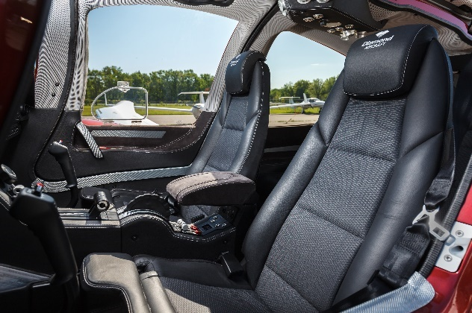
ADDITIONAL – INSTALLED OPTIONS
- Air Conditioning/RACC II System (powered by an additional alternator)
- TKS De-Icing system Certified for Flight into Known Icing (FIKI)
- Oxygen system
- 3rd row seating configuration (rear seating for two additional passengers)
SAFETY CONCEPT
- Composite cabin and safety seats
- “FAILSAFE” airframe and wing design
- Multipath Lightning Protection System
- Garmin ESP (Electronic Stability Protection)
OTHER EQUIPMENT
- 86 U.S. gallon Long Range Fuel Tank
- Baggage compartment
- Nose baggage compartment accessible from both sides

