Your flying “SUV”! G1000 NXi, Radar, Jepp Charts, and more.
Air conditioning, dual 5 and 7 seats configurations included. Full Factory warranty.

STATUS
- Factory new – ferry time only, Available for immediate delivery
POWER PLANT
- 2x Austro Engine AE 330 Turbocharged Common-Rail Injected 2.0 Liter Diesel Engine with 180 HP and EECU Single Lever Control System
- 2x MT Propeller MTV-6-R-C-F/CF 194-80 3-Blade Constant Speed Propeller

EXTERIOR SANDARD EQUIPMENT
- Hydraulic retractable landing gear
- Heated pitot tube and static port
- High-gloss Multilayer Paint (White)
- Variety of Exterior Striping Options
- Entry Steps and Entry Grips in Aircraft Color
- Registration Markings
- Electrically Operated Flap System
- Landing and Taxi Lights (HID-Xenon)
- Integrated LED Position and Strobe Lights
- Beringer Wheels and Brakes
INTERIOR
- Adjustable Backrest for Pilot and Copilot (with adjustable lumbar support)
- USB Power Outlets - Pilot, Copilot, Passenger’s 2nd Row Pax
- Instrument Lighting
- Overhead Ambient Cabin Light and Reading Lights and Map Lights
- Electrically Adjustable Rudder Pedals for Pilot/Co-pilot
- Pilot and Co-pilot Middle Armrest
- Dual Headset Plugs
(6-pin headset connector + standard jack connector)
- Sunvisors for Pilot and Copilot
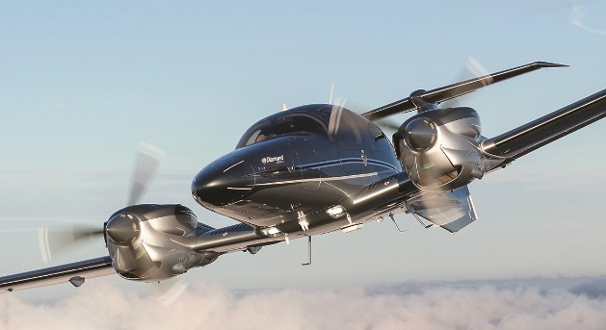
- Cargo Tray

AVIONICS
- Integrated Garmin G1000 NXi Glass Panel Cockpit, including:
- 2x Garmin GDU 1050 & 1055 10-Inch Flight Display
- Garmin GEA 71B Airframe/Engine Interface Unit
- 2x Garmin GIA 64 W COM/NAV/SBAS-GPS/GS/LOC
- Garmin GMA 1360 Digital Audio System
- Garmin GRS 79 Attitude Heading Reference System
- Garmin GDC 72 Digital Air Data Computer
- Garmin GMU 44 Magnetometer
- Garmin GFC 700 Automatic Flight Control System Including Yaw Damper
- Garmin GTX 335 R Remote ADS-B Out Transponder
- Garmin Flight Stream 510
- Garmin FliteCharts Approach Plates (subscription required)
- ELT 406 MHz
- 2nd Digital Standby Attitude Module (MD-302 SAM)
SAFETY CONCEPT
- Composite Cabin and Safety Seats (up to 26g)
- “FAILSAFE” Airframe and Wing
- Multipath Lightning Protection System
- 3-Point Safety Belts Automatic (all seats)
- Garmin ESP (Electronic Stability Protection)

OTHER EQUIPMENT- STANDARD
- 86 US gal (326 lt) Long Range Fuel Tank
- Baggage compartment
- Nose baggage compartment accessible from both sides
- Pitot Cover
- Tow bar, tool kit, control gust lock
- First aid kit, extinguisher, emergency axe, egress hammer

FACTORY WARRANTY & TRAINING
- Two-year factory warranty
- PistonPower airframe and engine maintenance program available at additional cost – call for details
- Factory-approved familiarization training

